A Project Report on

##### Improving Sign Language Accessibility with Deep Learning- Based Hand Gesture Recognition

Submitted in partial fulfilment of the requirements for the award of the degree of

**Bachelor of Technology in**

**Computer Science and Engineering**

Submitted By

**P. RAHUL (21701A05D9)**

**A. SAI THEERTHA (21701A05F6)**

**D. PRANEETHA (21701A05C8)**

**K. PRANAVA SAI (21701A05C6)**

Under the esteemed guidance of

**MISS. S. RIYAZ BANU M.Tech, ( Ph.D )**

Assistant Professor

Department of Computer Science and Engineering



**Department of Computer Science and Engineering**

**Annamacharya Institute of Technology and Sciences**

(An Autonomous Institution)

(Approved by AICTE, New-Delhi and affiliated to J.N.T.U, Anantapur) ( Accredited by NBA &NAAC with A+ Grade)

New Boyanapalli, Rajampet, Annamaiah (Dt), A.P-516 126

**2024-2025**



**CERTIFICATE**

This is to certify that the project entitled “**Improving Sign Language Accessibility with Deep Learning-Based Hand Gesture Recognition**” is submitted by

**P. RAHUL (21701A05D9)**

**A. SAI THEERTHA (21701A05F6)**

**D. PRANEETHA (21701A05C8)**

**K. PRANAVA SAI (21701A05C6)**

in partial fulfillment of requirements for the award of Degree of **Bachelor of Technology** in **“Computer science and Engineering”**, is a record of bonafide work carried out by them during the academic year 2024-2025.

**Project Guide Head of the Department**

Miss. S. Riyaz Banu M.Tech,(Ph.D) Dr. M. Subba Rao (Ph.D)

Assistant Professor , Department of CSE Professor & Head Dept. of CSE,

AITS, Rajampet Dean of Student Affairs,

AITS, Rajampet



**CERTIFICATE**

This is to certify that the project entitled “**Improving Sign Language Accessibility with Deep Learning-Based Hand Gesture Recognition**” is submitted by

**P. RAHUL (21701A05D9)**

**A. SAI THEERTHA (21701A05F6)**

**D. PRANEETHA (21701A05C8)**

**K. PRANAVA SAI (21701A05C6)**

in partial fulfillment of requirements for the award of Degree of **Bachelor of Technology** in **“Computer Science and Engineering”**, is a record of bonafide work carried out by them during the academic year 2024-2025.

Project viva-voce held on:

Internal Examiner External Examiner



**ANTI-PLAGIARISM CERTIFICATE**

This is to certify that the project/dissertation report titled **“Improving Sign Language Accessibility with Deep Learning-Based Hand Gesture Recognition”** submitted by

|  |  |  |
| --- | --- | --- |
| **P. RAHUL** | **with H.T. No.** | **(21701A05D9)** |
| **A. SAI THEERTHA** | **with H.T. No.** | **(21701A05F6)** |

**D. PRANEETHA with H.T. No. (21701A05C8)**

**K. PRANAVA SAI with H.T. No. (21701A05C6)**

of **Computer Science and Engineering** Department in partial fulfillment of **Bachelor of Technology** course contains a plagiarism of ____ percentage which is within the acceptable limits.

Date: Dean/Coordinator

Research & Development Cell

**Declaration**

We hereby declare that the project report entitled “**Improving Sign Language Accessibility with Deep Learning-Based Hand Gesture Recognition**” under the guidance of **Miss. S. Riyaz Banu** M.Tech,(Ph.D) Department of Computer Science and Engineering is submitted in partial fulfillment of the requirements for the award of the degree of Bachelor of Technology in Computer Science and Engineering.

This is a record of bonafide work carried out by us and the results embodied in project report have not been reproduced or copied from any source. The results embodied in this project report have been submitted to any other university or institute for the Award of any other Degree or Diploma.

Project Associates:

**P. RAHUL**

**A. SAI THEERTHA**

**D. PRANEETHA**

**K. PRANAVA SAI**

***ACKNOWLEDGEMENT***

*An endeavour of a long period can be successful only with the advice of many well- wishers. We take this opportunity to express our deep gratitude and appreciation to all those who encouraged us for successfully completion of the project work.*

*Our heartfelt thanks to our Guide* ***Miss. S. Riyaz Banu****, Department of Computer Science and Engineering, Annamacharya Institute of Technology and Sciences,Rajampet, for his valuable guidance and suggestions in analysing and testing throughout theperiod, till the end of the project work completion.*

*We wish to express sincere thanks and gratitude to* ***Dr. M. Subba Rao,*** *Head of the Department of Computer Science and Engineering, for his encouragement and facilities that were offered to us for carrying out this project.*

*We take this opportunity to offer gratefulness to our Principal* ***Dr. S. M. V. Narayana,***

*for providing all sorts of help during the project work.*

*We are very much thankful to* ***Dr. C. Gangi Reddy****, Honorary Secretary of the Annamacharya Educational Trust, for his help in providing good facilities in our college.*

*We would express our sincere thanks to all faculty members of* ***Computer Science and Engineering Department, batch-mates, friends and lab-technicians****, who have helped us to complete the project work successfully.*

*Finally, we express our sincere thanks to* ***our parents*** *who has provided their heartfelt support and encouragement in the accomplishment to complete this project successfully.*

Project Associates:

**P. RAHUL**

**A. SAI THEERTHA**

**D. PRANEETHA**

**K. PRANAVA SAI**

***ABSTRACT***

*This project focuses on developing a real-time Sign Language Recognition (SLR) system using Convolutional Neural Networks (CNNs) for accurate gesture recognition. The primary objective is to bridge communication gaps between deaf and hearing individuals by enabling computers to interpret sign language gestures. The system leverages CNNs, which are highly effective for image-based tasks, to automatically detect and classify hand gestures captured through a camera. The CNN model is trained on a dataset of hand gesture images and consists of convolutional layers for feature extraction, pooling layers for dimensionality reduction, and fully connected layers for classification. The model is optimized using the Adam optimizer and categorical cross-entropy loss function, ensuring efficient and accurate predictions. Dropout layers are incorporated to prevent overfitting and improve the model's generalization. The system is designed for real-time performance, making it suitable for various applications such as education, healthcare, and human-computer interaction. In addition to recognizing individual signs, future work aims to expand the system's capabilities by incorporating more gestures, improving accuracy, and integrating real-time feedback mechanisms, ensuring its broader accessibility and usability for diverse users. The system's flexibility also allows for easy scalability to accommodate additional sign language alphabets and phrases, fostering inclusivity and enhancing communication.*

***Keywords:*** *Sign Language Recognition, Convolutional Neural Networks, Gesture Recognition, Hand Gestures, Real-Time Processing, Deep Learning, Image Classification, Model Optimization, Categorical Cross- Entropy, Dropout Layers, Feature Extraction, Human-Computer Interaction, Accessibility, Inclusivity, Sign Language Dataset.*

###### TABLE OF CONTENTS

**TITLE PAGE No.**

Chapter 1 INTRODUCTION 1-3

1. Motivation 1

2.Definition of Sign Language 2-3

Chapter 2 LITERATURE SURVEY 4-8

Chapter 3 SYSTEM ANALYSIS 9-15

* 1. Existing System 9
     1. Disadvantages of Existing System 10
  2. Proposed System 10
     1. Advantages of Proposed System 11
  3. Models 12
  4. Modules Used 13
     1. Data Collection & Pre Processing 13
     2. Model Development 13
     3. Sign Language Detection 13
     4. Indian Sign Language (ISL) 13
     5. User Interface 13
  5. Algorithms Used 14-15

Chapter 4 SYSTEM REQUIREMENTS SPECIFICATION 16-18

* 1. Software Requirements 16
  2. Hardware Requirements 16
  3. Feasibility Study 16-17
     1. Economical Feasibility 17
     2. Technical Feasibility 17
     3. Behavioural Feasibility 17
  4. Functional and Non Functional Requirements 17-18

Chapter 5 SYSTEM DESIGN 19-27

* 1. Architecture Design 19
  2. Introduction to UML Diagrams 20

5.2.1 Goals 20

* 1. UML Notations 21-22
  2. UML Diagrams 23-28
     1. Use case Diagram 23
     2. Class Diagram 24
     3. Sequence Diagram 25
     4. Collaboration Diagram 25
     5. Deployment Diagram 26
     6. Activity Diagram 27
     7. Component Diagram 27

Chapter 6 SYSTEM CODING AND IMPLEMENTATION 28-39

* 1. Introduction to Python Programming Language 28-29
  2. Benefits of Python 29-30
  3. Libraries in Python 30-31
  4. Sample Code 32-39

Chapter 7 SYSTEM TESTING 40-48

* 1. Software Testing Techniques 40
  2. White Box Testing 40-41
  3. Black Box Testing 41-42

7.3.1 Strategies for Software Testing 42

* 1. Unit Testing 42-43
  2. Integration Testing 43-45
  3. Validation Testing 45
  4. System Testing 46
  5. Security Testing 46-47
  6. Performance Evaluation 47

7.9.1 Test Cases 48

**Chapter 8 RESULTS** **49-57**

8.1 Home Page 49

8.2 Data Loading And Model Training 49

8. 3 Live Sign Predictions 50

8.4 Image Processings 51

8.5 Live Predictions 52-55

8.6 Confusion Matrix 56

8.7 Classification Report 57

**Chapter 9 CONCLUSION AND FUTURE ENHANCEMENT** **58**

**REFERENCES** **59-60**

**PLAGIARISM REPORT**

**CONFERENCE PARTICIPATION CERTIFICATES**

#### LIST OF FIGURES & TABLES

Fig. No. Figures Page No.

* 1. Usage of Sign Languages Worldwide 3

5.1 Architecture Design 19

* + 1. Use Case Diagram 23
    2. Class Diagram 24
    3. Sequence Diagram 25
    4. Collaboration Diagram 25
    5. Deployment Diagram 26
    6. Activity Diagram 27
    7. Component Diagram 27
  1. Working Of Python Program 28
  2. Implementation of Python Program 29
  3. Home Page 49
  4. Data Loading And Model Training 49
  5. Live Sign Prediction 50
  6. Image Processings 51
  7. Live Predictions 52-55
  8. Confusion Matrix 56
  9. Classification Report 57

###### LIST OFABBREVIATIONS

* + - **AI**: Artificial Intelligence
    - **ML**: Machine Learning
    - **NN**: Neural Networks
    - **RF**:Random Forest (an ensemble method)
    - **SVR**: Support Vector Regression
    - **RMSE**: Root Mean Squared Error (a measure of prediction accuracy)
    - **MAE**: Mean Absolute Error (another measure of prediction accuracy)
    - **ANN**: Artificial Neural Networks
    - **DL:** Deep Learning
    - **CNN**: Convolutional Neural Networks
    - **RNN**: Recurrent Neural Networks
    - **LSTM**: Long Short-Term Memory (a type of RNN)
    - **DNN**: Deep Neural Networks
    - **SVM** : Support Vector Machine
    - **PCA**: Principal Component Analysis (a dimensionality reduction technique)
    - **ET**: Extra Trees (another ensemble method)
    - **GBT**: Gradient Boosted Trees
    - **XGB**: XGBoost (an optimized distributed gradient boosting library)
    - **GPS**: Global Positioning System (sometimes used in data collection)
    - **GIS**: Geographic Information System (for spatial data analysis)

### CHAPTER 1 INTRODUCTION

##### Introduction

* 1. Motivation

Sign language is a powerful mode of communication for individuals with hearing or speech impairments. However, the lack of understanding among the wider population creates a communication gap that can lead to social isolation for those relying on sign language. This project aims to bridge this gap by creating an intelligent system capable of recognizing sign language gestures in real time, enabling seamless interaction between sign language users and non-users. By utilizing advancements in machine learning and computer vision, the project aspires to foster inclusivity and promote equal opportunities for effective communication.

The rapid evolution of artificial intelligence (AI) and machine learning has opened new avenues for solving accessibility challenges. This project capitalizes on these advancements by employing Convolutional Neural Networks (CNNs) for gesture recognition. The motivation lies in the potential of technology to enhance accessibility, empowering individuals with impairments to participate fully in social, educational, and professional settings. By providing an accurate and real-time sign language detection system, this project demonstrates how technology can be a tool for empowerment.

Real-world sign language detection systems face several challenges, such as variations in hand gestures, differences in lighting conditions, and user-specific nuances. This project is motivated by the need to create a robust solution capable of addressing these practical issues. By utilizing MediaPipe for hand detection and implementing advanced preprocessing techniques, the system is designed to perform consistently across diverse environments. The inclusion of real-time webcam functionality underscores the project's commitment to practical and usable solutions. Another key motivation behind this project is to encourage the adoption of cutting-edge technologies in everyday life.

The user-friendly interface, developed using Streamlit, ensures that the system can be used by individuals without technical expertise. By simplifying the deployment of complex AI models, the project aims to raise awareness of how technology can be integrated into daily activities to solve real-world problems. This ease of use also makes it a valuable educational tool, highlighting the practical applications of machine learning.

At its core, this project is driven by a desire to create a meaningful social impact. By enabling effective communication between hearing and deaf communities, the system seeks to foster mutual understanding and respect. The long-term vision is to integrate such systems into public spaces, educational institutions, and workplaces, ensuring that individuals relying on sign language are not marginalized.

This project is also motivated by the broader vision of inspiring innovation in assistive technologies. By demonstrating the successful integration of machine learning, computer vision, and user-friendly interfaces, it sets the foundation for future advancements in accessibility solutions. Beyond sign language detection, similar techniques can be adapted to other domains, such as gesture-based human-computer interaction, rehabilitation technologies, or even virtual reality applications.

The scalability and adaptability of this system highlight its potential as a stepping stone for developers and researchers to explore new ideas. By addressing a critical need and showcasing the transformative power of AI, this project encourages a culture of innovation where technology is designed not just for convenience but for meaningful social change.

* 1. Definition

This project focuses on the development of an intelligent system for detecting and interpreting sign language using advanced computer vision and machine learning techniques. It involves leveraging algorithms capable of analyzing video and image data to recognize hand gestures and translate them into meaningful text or speech outputs, facilitating seamless communication between sign language users and non-users. By integrating state-of-the-art technologies, this system can bridge barriers and bring about a new level of inclusivity in communication. The project’s goal is to provide a scalable, accurate, and efficient solution that can function in real- time and under diverse environmental conditions.

At its core, the project aims to bridge the communication gap for the hearing and speech- impaired by creating an accessible, real-time solution. The system captures visual input, processes it using techniques like feature extraction and classification, and converts it into a comprehensible output. This ensures that users can interact naturally without the need for additional tools or extensive learning. By automating the translation process, the system enhances autonomy and independence for individuals relying on sign language. Moreover, the focus on real-time processing ensures that the communication experience is smooth and uninterrupted, mimicking natural conversation.

A key aspect of this project is its adaptability, ensuring that it recognizes a wide variety of gestures across different sign languages, catering to diverse linguistic needs. The system can be customized to incorporate regional and cultural variations, making it versatile and globally relevant. This adaptability not only supports cross-cultural communication but also encourages the preservation of unique sign language dialects. By training the system on large datasets with diverse gestures, it can provide consistent and reliable results in practical scenarios. This adaptability underscores the importance of inclusivity in technological advancements. The project's design also focuses on user-friendly .

Additionally, its ability to run on different platforms, such as mobile devices and desktops, expands its usability across various environments. Emphasis on clear feedback mechanisms and visual aids further enhances the user experience, ensuring that the system is approachable and practical for everyday use. By prioritizing simplicity and accessibility, the project ensures widespread adoption and meaningful impact.

Ultimately, this project is not just a technological innovation but also a step toward fostering equity and inclusivity in communication. It aligns with the broader goals of leveraging technology to empower underrepresented communities and promote social good. The development of such a system highlights the transformative potential of AI in addressing real- world challenges. By breaking down communication barriers, the project contributes to a more connected and compassionate society. It reflects the promise of technology as a tool for empowerment and positive change, making the world more inclusive for everyone.

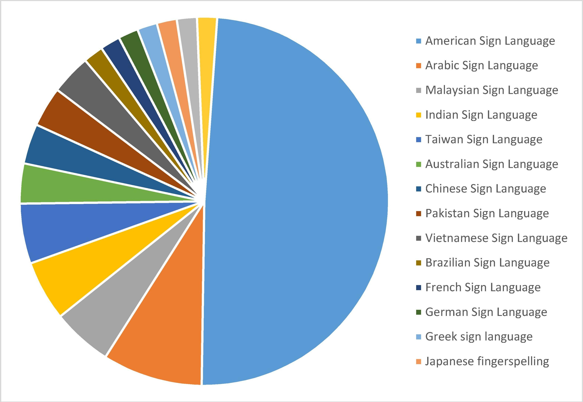

**Fig-1.2 : Usage of Sign Languages Worldwide**

### CHAPTER 2 LITERATURE SURVEY

###### LITERATURE SURVEY

1. **S. Alyami, H. Luqman, and M. Hammoudeh, ‘‘Isolated Arabic sign language recognition using a transformer-based model and landmark keypoints,’’ ACM Trans. Asian Low- Resource Lang. Inf. Process., vol. 23, no. 1, pp. 1–19, Jan. 2024.**

Alyami et al. (2024) presented a transformative approach to isolated Arabic Sign Language (ASL) recognition. The study utilized a transformer-based model combined with landmark keypoints to achieve robust and efficient recognition. By focusing on extracting significant features from hand and body landmarks, the model demonstrated improved accuracy in recognizing Arabic signs. The research emphasizes the importance of preprocessed data for better recognition and highlights the adaptability of transformer models in low-resource language settings. The results showcased the model's scalability, providing a foundation for future advancements in Arabic Sign Language recognition systems.

1. **G. J. Shin, A. S. M. Miah, K. Suzuki, K. Hirooka, and M. A. M. Hasan, ‘‘Dynamic Korean sign language recognition using pose estimation based and attention-based neural network,’’ IEEE Access, vol. 11, pp. 143501–143513, 2023.**

Shin et al. (2023) developed a dynamic recognition system for Korean Sign Language using pose estimation and attention-based neural networks. Their study emphasized the importance of accurate pose detection for reliable sign interpretation. The integration of attention mechanisms improved the system’s ability to capture subtle variations in gestures. This research highlighted the adaptability of attention-based models in low-resource sign languages, paving the way for future innovations. By focusing on real-time recognition, the system enhanced accessibility for Korean Sign Language users in everyday communication. The proposed approach also demonstrated its scalability to other sign languages with minimal adjustments. The system’s potential to operate in resource-constrained environments further solidified its practical value.

1. **N. Naz, H. Sajid, S. Ali, O. Hasan, and M. K. Ehsan, ‘‘Signgraph: An efficient and accurate pose-based graph convolution approach toward sign language recognition,’’ IEEE Access, vol. 11, pp. 19135–19147, 2023.**

Naz et al. (2023) proposed SignGraph, a pose-based graph convolution framework for efficient sign language recognition. By leveraging pose estimation, the model reduced computational complexity while maintaining high accuracy. The approach focused on simplifying sign interpretation for real-world applications. SignGraph’s efficiency and accuracy highlight its potential as a lightweight solution for mobile and embedded systems. This approach also allows for scalable deployment in various settings, enhancing accessibility for deaf individuals in diverse environments. The model's flexibility makes it adaptable to different sign languages contexts.

1. **A. Duarte, S. Palaskar, L. Ventura, D. Ghadiyaram, K. DeHaan, F. Metze, J. Torres, and**

**X. Giro-i-Nieto, ‘‘How2Sign: A large-scale multimodal dataset for continuous American sign language,’’ in Proc. IEEE/CVF Conf. Comput. Vis. Pattern Recognit. (CVPR), Jun. 2021, pp. 2734–2743.**

Duarte et al. (2021) presented How2Sign, a multimodal dataset designed for continuous ASL recognition. The dataset includes synchronized video, depth, and text data, allowing researchers to train robust machine learning models. With over 80 hours of annotated ASL content, How2Sign has become an essential resource for advancing ASL recognition systems. The research highlights the challenges of continuous sign recognition and provides solutions through detailed annotations and multimodal data. The study's contributions lay the foundation for seamless integration of ASL recognition in practical applications. The dataset's diverse modalities enable a deeper understanding of sign dynamics, enhancing model performance in real-world environments.

1. **J. Zheng, Y. Chen, C. Wu, X. Shi, and S. M. Kamal, ‘‘Enhancing neural sign language translation by highlighting the facial expression information,’’ Neurocomputing, vol. 464,**

**pp. 462–472, Nov. 2021.**

Zheng et al. (2021) explored methods to improve neural sign language translation by incorporating facial expression data. The study emphasized that facial expressions carry critical contextual information in sign languages. By integrating facial data with gesture recognition, the system achieved higher translation accuracy. The approach demonstrated the importance of multimodal inputs in creating reliable sign language models. The study's focus on neural architectures ensured scalability and adaptability to diverse sign languages. Additionally, the research showcased the potential for real-time translation systems to improve communication accessibility for deaf individuals. This work paves the way for more sophisticated, context-aware sign language translation systems.

1. **L. Meng and R. Li, ‘‘An attention-enhanced multi-scale and dual sign language recognition network based on a graph convolution network,’’ Sensors, vol. 21, no. 4, p. 1120, Feb. 2021.**

Meng and Li (2021) introduced a graph convolution network for multi-scale sign language recognition. Their attention-enhanced network captured complex dependencies between hand movements and gestures. By employing a graph-based approach, the model demonstrated superior performance in interpreting complex signs. The study emphasized the importance of multi-scale features in recognizing diverse sign patterns. This approach set a new benchmark for graph-based sign language recognition models.

1. **D. Li, C. R. Opazo, X. Yu, and H. Li, ‘‘Word-level deep sign language recognition from video: A new large-scale dataset and methods comparison,’’ in Proc. IEEE Winter Conf. Appl. Comput. Vis. (WACV), Mar. 2020, pp. 1448–1458.**

Li et al. (2020) proposed a novel framework for word-level sign language recognition using deep learning. Their study introduced a large-scale dataset and compared several methods for video- based recognition. By focusing on word-level distinctions, the framework improved accuracy in interpreting contextually similar signs. The research demonstrated the power of deep learning in extracting complex spatiotemporal features from videos. This work significantly advanced sign language recognition, particularly in scenarios involving large vocabularies and subtle gesture variations.

1. **X. Liang, A. Angelopoulou, E. Kapetanios, B. Woll, R. A. Batat, and T. Woolfe, ‘‘A multi- modal machine learning approach and toolkit to automate recognition of early stages of dementia among British sign language users,’’ in Proc. Eur. Conf. Comput. Vis., 2020, pp. 278–293.**

Liang et al. (2020) developed a multi-modal machine learning toolkit for detecting early dementia in British Sign Language users. The study combined facial, gestural, and linguistic features to analyze subtle cognitive impairments. Their approach highlights the potential of sign language data in identifying health-related challenges. By focusing on British Sign Language, the research introduced a unique application of sign recognition systems in healthcare. This pioneering work bridges the gap between sign language research and medical diagnostics, emphasizing inclusivity in medical AI. The integration of multiple data sources enhanced the accuracy of dementia detection, contributing to early intervention strategies.

1. **O. Koller, N. C. Camgoz, H. Ney, and R. Bowden, ‘‘Weakly supervised learning with multi-stream CNN-LSTM-HMMs to discover sequential parallelism in sign language videos,’’ IEEE Trans. Pattern Anal. Mach. Intell., vol. 42, no. 9, pp. 2306–2320, Sep. 2020.**

Koller et al. (2020) presented a weakly supervised learning framework combining CNN, LSTM, and HMM models. Their approach focused on discovering sequential parallelism in sign language videos. By employing multi-stream architectures, the system captured diverse features from gestures. The research demonstrated the power of hybrid models in improving recognition accuracy. This work remains a reference point for weakly supervised learning in sign language recognition. By reducing the need for extensive labeled data, the framework made sign language recognition more feasible in real-world scenarios. It also set the stage for future research in combining deep learning models with minimal supervision for language processing tasks.

1. **X. Liang, A. Angelopoulou, E. Kapetanios, B. Woll, R. A. Batat, and T. Woolfe, ‘‘A multi-modal machine learning approach and toolkit to automate recognition of early stages of dementia among British sign language users,’’ in Proc. Eur. Conf. Comput. Vis., 2020, pp. 278–293.**

Liang et al. (2020) also contributed a unique toolkit for early dementia detection in British Sign Language users. Their approach integrated machine learning with multimodal data to analyze cognitive impairments. The toolkit’s ability to detect subtle changes in signing behavior highlighted its effectiveness. By focusing on healthcare applications, the study emphasized the potential of sign recognition systems beyond communication. The integration of behavioral patterns and cognitive markers enabled early diagnosis, improving outcomes for individuals. This approach also highlighted the importance of personalized healthcare, showing how sign language data can be used for customized treatment plans.

1. **R. Cui, H. Liu, and C. Zhang, ‘‘A deep neural framework for continuous sign language recognition by iterative training,’’ IEEE Trans. Multimedia, vol. 21, no. 7, pp. 1880–1891, Jul. 2019.**

Cui et al. (2019) introduced a deep neural framework for continuous sign language recognition using iterative training. Their model employed spatiotemporal feature extraction to interpret complex gestures and capture dynamic sign variations. By focusing on continuous recognition, the study addressed challenges associated with sentence-level signing. The iterative training method enhanced the model’s robustness, making it more reliable for real-world applications. This work paved the way for advancements in seamless sign language interpretation, ultimately improving accessibility for deaf individuals in diverse environments.

1. **N. K. Caselli, Z. S. Sehyr, A. M. Cohen-Goldberg, and K. Emmorey, ‘‘ASL-LEX: A lexical database of American sign language,’’ Behav. Res. Methods, vol. 49, no. 2, pp. 784– 801, Apr. 2017.**

Caselli et al. (2017) introduced ASL-LEX, a comprehensive lexical database for American Sign Language. This database provides detailed information on the phonological, morphological, and frequency-related properties of ASL signs. It offers researchers and practitioners an invaluable resource to study sign linguistics and improve recognition systems. The dataset's breadth enables in-depth analysis of sign patterns, supporting machine learning and linguistic research. By bridging the gap between data availability and technical advancements, ASL-LEX remains a cornerstone for ASL-related studies. Its extensive coverage of ASL vocabulary makes it a foundational tool for developing more accurate and efficient sign language processing models.

1. **D. Bahdanau, K. Cho, and Y. Bengio, ‘‘Neural machine translation by jointly learning to align and translate,’’ 2014, arXiv:1409.0473.**

Bahdanau et al. (2014) proposed an innovative neural machine translation framework, which was later adapted for sign languages. Their approach employed attention mechanisms to align and translate sequential data. Although not directly designed for sign language, the methodology's application to linguistic data established its relevance. The attention-based approach inspired further advancements in sign language translation, emphasizing the adaptability of machine translation methods. This work significantly impacted the development of more accurate and context-aware sign language translation systems. The framework laid the groundwork for future research in multimodal translation models, including those for sign languages. The use of attention mechanisms continues to influence models in achieving more accurate translations.

1. **N. Pugeault and R. Bowden, ‘‘Spelling it out: Real-time ASL fingerspelling recognition,’’ in Proc. IEEE Int. Conf. Comput. Vis. Workshops (ICCV Workshops), Nov. 2011, pp. 1114– 1119.**

Pugeault and Bowden (2011) developed a system for real-time recognition of ASL fingerspelling, emphasizing the significance of user-friendly interfaces for deaf communities. The system employed advanced computer vision techniques to capture hand movements and convert them into interpretable text. The integration of real-time capabilities into the model ensured seamless interaction between sign language users and technology. Despite being an early contribution, this work set the stage for subsequent advancements in ASL recognition. Its focus on efficiency and simplicity remains a benchmark in the development of assistive technologies.

1. **U. von Agris, M. Knorr, and K.-F. Kraiss, ‘‘The significance of facial features for automatic sign language recognition,’’ in Proc. 8th IEEE Int. Conf. Autom. Face Gesture Recognit., Sep. 2008, pp. 1–6.**

Agris et al. (2008) investigated the role of facial features in improving automatic sign language recognition. Their study emphasized that non-manual cues like facial expressions significantly enhance the contextual understanding of sign gestures. The research introduced novel methodologies for integrating facial recognition with manual sign interpretation. By doing so, they improved the overall accuracy and reliability of sign language models. Their findings underline the critical role of multi-modal data in building holistic recognition systems, paving the way for future explorations into non-manual sign recognition. Moreover, this approach highlighted the importance of capturing facial dynamics for advancing sign language technology.

### CHAPTER 3 SYSTEM ANALYSIS

###### SYSTEM ANALYSIS

An in-depth examination of project data using a variety of phases, methods, functions, and entities constitutes the analysis of computer data, project data, algorithm data, and other inner and outer data relevant to the proposed study. System analysis is a collection of scientific methods for figuring out the specifications for project task design. For the design of the suggested system, system analysis examined a variety of functional and non-functional requirements. In order to create a logical model of the system, the current system analysis has examined numerous publications pertinent to the project's work and planned the design using a variety of tools, including class diagrams, sequence diagrams, data flow diagrams, and data dictionaries.

###### EXISTING SYSTEM :

Several systems have been developed for real-time gesture recognition, leveraging advancements in computer vision, deep learning, and human-computer interaction. MediaPipe Hands by Google is a prominent framework that provides real-time hand tracking and gesture recognition capabilities. Its strength lies in its lightweight nature, making it suitable for mobile and web applications. It employs a machine learning pipeline that detects hand landmarks and gestures efficiently. However, its limitations include challenges with occlusions (e.g., when hands overlap) and difficulties in detecting gestures under varying lighting conditions or unconventional hand orientations. Another noteworthy system is Leap Motion, a hardware-based solution designed for precise hand gesture detection.

This system excels in tracking finger movements and gestures within its designated sensor range. Leap Motion’s strength is its high accuracy and ability to detect subtle finger movements, making it ideal for virtual reality and gaming applications. However, its reliance on specialized hardware limits its scalability and accessibility, especially for users without the device. OpenPose is another widely-used system that extends gesture recognition to full-body pose estimation, including hand gestures. Its multi- person tracking capability is a significant advantage, enabling applications in group interactions and sign language recognition.

However,OpenPose requires significant computational resources, which can hinder its performance on devices with limited processing power, such as smartphones or embedded systems. Additionally, its setup and preprocessing requirements can be complex for non-expert users. Lastly, custom CNN-based models have been explored in academic and industrial settings, tailored for specific applications like sign language recognition or touchless interfaces.

These models offer flexibility, allowing developers to fine-tune them for specific datasets and requirements. However, they often require extensive training data and computational resources. The lack of generalization to unseen environments or gestures is another drawback, making it challenging to deploy them in dynamic real-world scenarios.

###### DISADVANTAGES :

Despite significant advancements in gesture recognition systems, existing solutions face notable disadvantages that limit their efficiency and applicability in diverse scenarios. Many systems, like MediaPipe Hands, struggle with occlusion issues, where overlapping or partially visible hands affect accuracy. They are also sensitive to environmental conditions such as lighting, background clutter, and camera resolution, making them less reliable in dynamic or uncontrolled settings. Hardware-dependent systems like Leap Motion require specialized devices, which increases costs and reduces accessibility, particularly in resource-constrained environments.

Solutions like OpenPose, while powerful, demand substantial computational resources and are challenging to implement on low-power devices like mobile phones or embedded systems. Furthermore, these systems often lack robustness against variations in hand orientations, skin tones, or cultural gesture differences. Many custom deep learning models require vast amounts of labeled training data, which can be difficult and expensive to collect. Additionally, the generalization capability of these models is often limited, resulting in poor performance when exposed to unseen gestures or novel environments.

Real-time processing is another challenge, as systems may lag or fail to deliver immediate responses in scenarios requiring high-speed interactions, such as gaming or robotic control. Moreover, the user experience can be hindered by the complexity of setup, requiring calibration or pre configuration that is not user-friendly. Privacy concerns also emerge when systems rely on capturing and processing sensitive user data, particularly for cloud-based implementations. Collectively, these limitations highlight the need for more adaptable, efficient, and user-centered gesture recognition systems to address the diverse demands of real-world applications.

Additionally, many existing systems lack cross-platform compatibility, limiting their integration into a wide range of devices and ecosystems. This further emphasizes the need for scalable, flexible solutions that balance accuracy, efficiency, and user convenience.

###### PROPOSED SYSTEM:

The proposed system is designed to facilitate seamless communication by recognizing sign language gestures using machine learning techniques. At its core, the system employs a Convolutional Neural Network (CNN) to classify hand gestures into specific sign language symbols. This solution bridges the communication gap for individuals with hearing or speech impairments, enabling real-time translation of gestures into textual or auditory formats. To enhance performance and robustness, the system incorporates data preprocessing and augmentation techniques. Input images are resized, normalized, and subjected to transformations like flipping, rotation, and zooming. These augmentations ensure that the model generalizes well across diverse conditions, such as changes in hand orientation and environmental noise.

The preprocessing pipeline ensures that the input is consistent and optimized for training and inference, making the model resilient to variations in input data. The real-time gesture recognition capability of the system is a standout feature. Using a live camera feed, the system captures video frames, processes them, and predicts the corresponding gestures with minimal latency. This real-time processing ensures smooth and efficient interactions, making the system practical for daily use. The recognized gestures can be displayed as text on a screen or converted into spoken language, depending on the application's requirements.

Another highlight is the scalability of the proposed solution. The system is designed to be flexible, allowing it to expand to accommodate new gestures or additional sign languages. By retraining the model on extended datasets, it can adapt to various regional or cultural sign languages, making it a versatile tool. Its modular architecture also enables deployment on different platforms, such as desktops, smartphones, or embedded devices, ensuring accessibility to a broad user base. While the system offers significant benefits, it also faces some challenges. Dependence on high- quality datasets and consistent lighting conditions may impact performance in uncontrolled environments.

Future enhancements could focus on addressing these limitations by integrating advanced preprocessing techniques, improving model architectures, and incorporating additional context, such as facial expressions or body movements. Expanding the system to support full-body sign language and sentence-level interpretation would further enhance its utility, bringing it closer to real-world applications.

###### ADVANTAGES :

The proposed sign language gesture recognition system offers significant advantages in bridging communication gaps, making it an invaluable tool for individuals with hearing or speech impairments. By leveraging machine learning, particularly Convolutional Neural Networks (CNNs), the system provides high accuracy in gesture recognition, even in complex and diverse environments. The use of advanced classification algorithms ensures that the system can identify subtle differences between similar gestures, making it reliable for real-world applications.

This capability fosters inclusivity and empowers users to communicate more effectively in their personal and professional lives. One of the standout features of the proposed system is its real- time processing capability, which allows for seamless interaction between the user and the system. By utilizing live video feeds, the system can capture and interpret gestures instantaneously, delivering results without noticeable delays.

This ensures a natural and fluid communication experience, critical for scenarios such as classrooms, workplaces, and public services. The low-latency performance enhances the usability of the system, making it practical for deployment in dynamic, fast-paced environments.

This flexibility ensures that the system remains relevant and useful across diverse regions, cultural contexts, and languages. Furthermore, its modular architecture allows for seamless integration with various devices, including smartphones, tablets, and wearable technology. This multi-platform compatibility makes it accessible to a broader audience, ensuring that the benefits reach as many users as possible.

Another critical advantage is the incorporation of robust preprocessing and augmentation techniques during model training. These methods improve the system's resilience to challenges such as variations in hand orientation, background clutter, and lighting conditions. The enhanced generalization capability ensures that the model performs well across diverse scenarios, reducing errors and improving user satisfaction.

Such reliability is particularly important in environments where consistent lighting or controlled settings are not guaranteed. Lastly, the system has the potential to transform accessibility and inclusivity in communication by providing a practical, user-friendly solution for bridging the gap between individuals using sign language and those who do not. Its ability to translate gestures into text or speech enhances social interactions and fosters greater independence for users with hearing or speech impairments. Moreover, its potential applications extend to education, healthcare, customer service, and beyond, making it a versatile and impactful innovation.

###### MODELS :

In the proposed system, a Convolutional Neural Network (CNN) model is used for sign language detection. CNNs are a class of deep learning models that are highly effective in image processing tasks. They are specifically designed to automatically and adaptively learn spatial hierarchies of features through the use of convolutional layers. In the case of sign language detection, CNNs excel at recognizing patterns in images such as hand gestures and shapes by utilizing convolutional operations to detect edges, textures, and more complex features.

These models typically consist of multiple convolutional layers, pooling layers, and fully connected layers, which help in classifying images into predefined categories, such as letters in sign language. The architecture of the CNN used in the code follows a standard approach for image classification tasks. It starts with Conv2D layers, which apply filters to input images to capture local patterns such as edges and textures.

These layers are essential for detecting the most basic features in the image, which will later be used to understand more complex features. The filters are learned through backpropagation during the training process, allowing the network to specialize in extracting relevant features for the specific task. Next, MaxPooling2D layers are introduced to reduce the spatial dimensions of the image after each convolution. Pooling operations help in reducing the number of parameters, which leads to a reduction in computational cost and prevents overfitting.

###### MODULES USED

* + 1. Data Collection & Pre Processing

Sign language detection uses datasets like ASL, ISL, and Kaggle’s Sign Language Digits dataset. These contain labeled hand gesture images for training deep learning models. Preprocessing steps like resizing, normalization, and augmentation improve model accuracy.

* + 1. Model Development

This module handles building and training a CNN-based deep learning model.The model is designed with layers like Conv2D, MaxPooling, and Dense.It is trained using the preprocessed data to recognize sign gestures.Model performance is evaluated using accuracy and loss metrics.The trained model is saved for real-time prediction in later stages.

3.4.3 Sign Language Detection

This module captures real-time hand gestures using a webcam.MediaPipe is used to extract hand landmarks from the live video feed.These landmarks are processed and passed to the trained model.The model predicts the corresponding sign language character.The detected sign is displayed instantly to the user on-screen.

3.4.4 Indian Sign Language (ISL)

ISL has unique gestures requiring specialized datasets and deep learning models. CNNs and RNNs, combined with OpenCV and MediaPipe, help detect ISL signs, improving accessibility in India.

3.4.5 User Interface

This module is developed using Streamlit for user interaction.It includes pages likeHome,Scan, About, and Model Info.Users can access real-time scanning and view prediction results.Graphical outputs like accuracy and charts are also displayed.The UI integrates all modules into a smooth and interactive system.

###### ALGORITHMS USED

**Convolutional Neural Network (CNN) :**

CNNs are particularly well-suited for tasks involving image data, like sign language detection, because they excel at learning spatial hierarchies. In this system, the convolutional layers of the CNN play a crucial role in extracting relevant features from input images. These layers use filters (or kernels) that move across the image, applying a convolution operation to identify low-level features such as edges, textures, and shapes.

As the network goes deeper, it can recognize increasingly complex patterns such as hand positions, gestures, and even subtle movements, which are essential for sign language recognition. By leveraging the hierarchical nature of convolution, the CNN learns different levels of abstraction. Early layers detect basic patterns like lines, while deeper layers combine these to form higher-level features, such as hand shapes and finger orientations.

To reduce the computational complexity and prevent overfitting, pooling layers are added after convolutional layers. These layers serve to downsample the feature maps, retaining only the most important features while reducing the image’s spatial dimensions. The most common pooling technique is max pooling, which selects the maximum value from a specified region of the feature map, ensuring that the most dominant features are preserved.

Pooling not only reduces the computational load by lowering the number of parameters but also introduces a level of spatial invariance, meaning that the model can recognize hand gestures regardless of slight variations in position or orientation. This makes the system more robust and adaptable to real-world variations in sign language gestures. After feature extraction and dimensionality reduction, the CNN transitions to the fully connected layers (FC layers).

These layers are responsible for combining the features learned in previous layers and mapping them to output classes, such as the specific sign language gesture being made. The Softmax activation function is typically used in the final layer to produce a probability distribution over the possible gesture classes. In the context of sign language recognition, the fully connected layers work to correlate the complex features extracted from the image (such as finger positions, hand shape, etc.) to predefined classes representing different gestures. The network adjusts the weights of these connections during training to maximize accuracy in classifying gestures, refining its ability to recognize a wide range of hand gestures.

To combat overfitting, which is a common problem when training deep neural networks, dropout layers are incorporated into the model. Dropout works by randomly “dropping” a proportion of neurons during training, meaning they are temporarily removed from the network during each forward and backward pass. This forces the network to learn more robust features by preventing it from becoming too reliant on any particular neuron.

The effect of dropout is that the network becomes more generalized and less likely to overfit on the training data. In the case of sign language detection, dropout helps ensure that the model does not memorize specific hand shapes or gestures but instead learns the broader patterns that are consistent across different samples of the same gesture. The model is trained using categorical cross-entropy as the loss function, which is well-suited for multi-class classification problems like sign language gesture recognition.

The goal of training is to minimize the loss, which represents the difference between the model’s predictions and the actual labels. During training, the Adam optimizer is used, which adapts the learning rate based on the model's performance to ensure efficient convergence. The training process involves multiple iterations where the model adjusts the weights of the filters and neurons in the network. By using backpropagation, the gradients of the loss function are calculated and propagated back through the network, enabling the model to update its parameters in a way that minimizes error. Over time, this process allows the CNN to learn to recognize hand gestures more accurately and reliably.

After training, the model is evaluated on unseen test data to assess its ability to generalize to new sign language gestures. This step is crucial to ensure that the model has not overfitted to the training data and can accurately classify gestures it has never seen before. The performance is typically measured using metrics such as accuracy, precision, and recall, which provide insights into how well the model performs in real-world scenarios.

CNNs are especially useful for tasks like sign language recognition because they eliminate the need for hand-crafted feature extraction methods. By automatically learning the most relevant features from raw image data, CNNs make the system highly flexible and scalable, able to recognize a wide variety of gestures and adapt to different sign languages or even new gestures in the future.

**CHAPTER-4**

**SYSTEM REQUIREMENTS SPECIFICATION**

#### SYSTEM REQUIREMENTS SPECIFICATION

Software requirements specifications (SRS), also known as software system requirements specifications, offer a comprehensive description of the duties that a system must do. The use cases in this section describe how the software interacts with its users. The SRS also contains non-functional specifications in addition to the usage case. Non-functional specifications are criteria that limit design or execution (such as requirements for performance engineering, quality standards or design constraints).

###### SOFTWARE REQUIREMENTS

* Operating System : Windows 11
* Server-side Script : Python
* IDE : Visual Studio Code
* Framework : Streamlit

###### HARDWARE REQUIREMENTS

* Processor : I3/Intel Processor

 RAM : 4GB

* Hard Disk : 160GB
* Monitor : SVGA

###### FEASIBILITY STUDY

Finding the optimum solution to meet performance requirements is the goal of a feasibility study. They include a description of identification, an assessment of potential system candidates, and the choice of the best candidate.

* Economic Feasibility
* Technical Feasibility
* Behavioral Feasibility
  + 1. Economic Feasibility:

The most popular way for determining whether a potential system is effective is economic analysis. The process, more popularly known as cost/benefit analysis, entails calculating savings and benefits to see if they outweigh expenses. If they do, the decision to design and execute the system is then made. If the system is to have an enhancement that can be approved, more justification or changes must be made.

* + 1. Technical Feasibility:

The existing computer system's capabilities to accommodate the planned expansion are the focus of the technical analysis (hardware, software, etc.). To allow technical advancement, there must be financial concerns. The project is deemed unfeasible if funding is a severe restriction.

* + 1. Behavioral Feasibility:

The strength of the user staff's expected opposition to the creation of a computerised system should be estimated. The introduction of a potential system necessitates extra effort to inform, persuade, and train the current methods of thinking about business. It is well known that computer installations have something to do with understanding.

* + 1. Benefits of Doing a Feasibility Study:

The following list summarises some of the benefits of doing a feasibility study.

* + - * The analysis portion of this study, which is being created as the first stage of the software development life cycle, assists in thoroughly examining the system requirements.
      * Aids in determining the risk variables associated in creating and implementing the system.
      * Planning for risk analysis is aided by the feasibility study.
      * Cost-benefit analyses made possible by feasibility studies enable effective operation of the system and organisation.
      * Planning for training developers to put the system into place is aided by feasibility studies.

###### FUNCTIONAL AND NON-FUNCTIONAL REQUIREMENTS

Analysis of requirements is a vital step in determining whether a system or software project will be successful. Functional requirements and non-functional requirements are the two main categories of requirements.

Functional requirements define what the system should do, specifying its behavior and the interactions between the system and its users.

Non-functional requirements, on the other hand, describe how the system performs its functions, focusing on attributes such as performance, usability, and reliability. Thorough analysis of these requirements helps ensure that the final product meets user needs and expectations while adhering to technical and operational constraints. Additionally, it helps in identifying potential challenges early in the development process, allowing for proactive measures to address them.

* + 1. Functional Requirements:

These are the necessities that the system must provide in order to meet the end user's individual requests for basic amenities. The contract must unavoidably stipulate that each of these functionalities be built into the system.They are portrayed or described as input to be provided to the system, an operation to be carried out, and an anticipated output. Unlike non-functional needs, they are essentially the user-stated requirements that can be seen immediately in the finished product.

An illustration of a functional requirement is:

1. Whenever a user logs into the system, they must authenticate themselves.
2. In the event of a cyberattack, shut down the system.
3. When a user registers for the first time on a software system, a verification email is automatically sent to them.
   * 1. Non-functional requirements:

In essence, they are the quality requirements that the system must meet in accordance with the project contract. Depending on the project, different aspects may be given varying degrees of priority or implementation. These are also known as non-behavioral requirements.

They primarily address things like: Portability, Security, Maintainability, Reliability, Scalability, Performance, Reusability, Flexibility.

Non-functional needs examples include:

* With respect to such an activity, emails should be sent no more than 12 hours afterwards.
* Each request should be processed in less than ten seconds.

## CHAPTER-5 SYSTEM DESIGN

#### SYSTEM DESIGN

###### ARCHITECTURE DESIGN

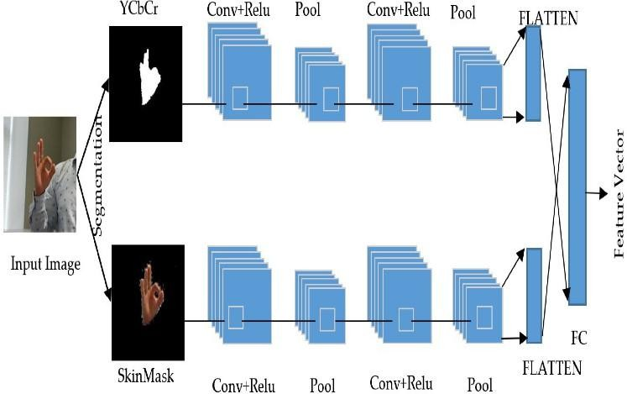

The system architecture for sign language recognition efficiently processes and classifies hand gesture images using a modular approach. It starts with data acquisition, gathering diverse images of hand gestures. These images undergo preprocessing, including resizing, normalization, and augmentation, to ensure the model performs well across varied conditions.

The core of the system is a CNN model that begins with convolutional layers to extract spatial features like edges and patterns. These are followed by pooling layers to reduce feature map dimensions while retaining key information. Dropout layers are included to prevent overfitting and enhance the model’s generalization capabilities. The features are then passed through fully connected layers, where the network associates extracted patterns with gesture classes.

The final layer uses a softmax function to output probabilities for each class, enabling multi-class classification. A loss function, like categorical cross-entropy, and an optimizer, such as Adam, guide the model’s training by minimizing errors. To ensure robustness, the model undergoes iterative validation during training to fine-tune hyperparameters.

The system is designed for scalability, allowing it to adapt to different sign languages or alphabets with minimal modifications. Real-time recognition is achieved through efficient deployment on platforms with adequate computational resources.

* 1. **INTRODUCTION TO UML DIAGRAMS**

As the strategic importance of software grows, the industry searches for ways to automate software development, enhance quality, cut costs, and accelerate time-to-market. Component technology, visual programming, patterns, and frameworks are a few examples of these techniques. When a company grows, it searches for ways to control the scope and size of its systems and reduce their complexity. The Internet has also made many structural problems worse while simplifying some tasks. The Unified Modeling Language (UML) was created to satisfy these requirements. Simply described, systems design is the process of creating a system's architecture, components, modules, interfaces, and data to meet certain goals. This can be accomplished fast using UML diagrams. Throughout the project, eight fundamental UML diagrams were explained.

* Use Case Diagram
* Class Diagram
* Activity Diagram
* Sequence Diagram
* Collaboration Diagram
* Deployment Diagram
  + 1. **GOALS**
* Make available to users a ready-to-use, expressive visual modeling language that enables them to create and share meaningful models.
* Provide mechanisms for extendibility and specialisation in order to broaden the scope of the core concepts.
* Refrain from using specific programming languages or development processes.
* Lay the groundwork for a formal understanding of the modeling language. The following are the primary goals of the UML design:
  + Encourage the growth of the market for OO tools.
  + Help with the implementation of higher-level development concepts like collaborations, frameworks, patterns, and components.

###### UML NOTATIONS

|  |  |  |  |
| --- | --- | --- | --- |
| **S.NO** | **SYMBOL**  **NAME** | **NOTATION** | **DESCRIPTION** |
| 1. | Initial Activity |  | This diagram depicts the flows initial point or activity. |
| 2. | Final Activity |  | A bull’s eye icon marks the conclusion of the activity  graphic. |
| 3. | Activity |  | Represented by a  rectangle with a rounded edge. |
| 4. | Decision |  | One that requires  decision-making. |
| 5. | Use Case |  | Explain how a user a n d a s y s t e m communicate. |
| 6. | Actor |  | A function a user has  in relation to the system. |
| 7. | Object |  | A Real-Time entity. |
| 8. | Message |  | To communicate between the lives of  object. |
| 9. | State |  | It depicts events  that occur during an objects lifetime. |

|  |  |  |  |
| --- | --- | --- | --- |
| 10. | Initial State |  | Represents the  objects initial state. |
| 11. | Final State |  | Represents the  objects final state. |
| 12. | Transition |  | Label the transition with the event that triggered it and the action that result  from it . |
| 13. | Class |  | A group of items with similar structures and  behaviours. |
| 14. | Association |  | Relationship between classes. |
| 15. | Generalization |  | Relationship between more general class and a more specific  class. |

###### UML DIAGRAMS

* + 1. **USE CASE DIAGRAM**

A use case diagram is a form of behavioural diagram created from use-case research and is an example of software engineering's use of the Unified Modeling Language (UML). Its goal is to demonstrate the actors, goals (represented as use cases), and any dependencies among those use cases in a system. The main goal of a use case diagram is to show which system functions are executed for each actor. It is clear what the system's actor roles are. Throughout the requirements elicitation and analysis phase, use cases are used to illustrate the capabilities of the system. To describe how the technology works when not in use, use scenarios are utilised. Use cases are inside the system, whereas actors are outside. A device border separates a group of use cases in the case diagram, which is a diagram of actors. The application diagram is necessary to comprehend the element's behaviour.

1. Sequences highlight the relationship to outside circumstances.
2. This covers both the performer's job and the system.
3. Actors can portray people or a building.

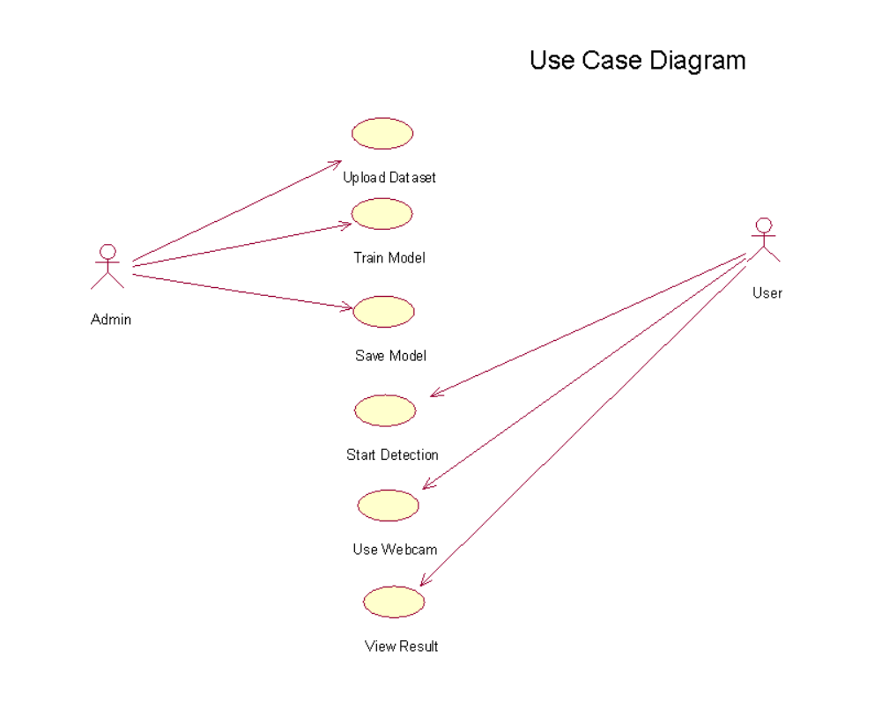

**Figure 5.4.1: Use Case Diagram**

* + 1. **CLASS DIAGRAM**

A class diagram in the Unified Modeling Language (UML) is a type of static structural diagram used in software engineering to show the classes, properties, and relationships between the classes that make up a system.

It is utilised in analysis to show the system's specifics. Architecture examines the class diagram to determine which classes have an excessive number of functions and, if any do, whether they should be divided. The connections between the classes are made. The Class Diagram is a tool used by developers to create classes. A class diagram is a group of related objects that are all connected and have the same features, operations, relationships, and connections and regulations referred to as semantics. A class is a huge group of items in a production.

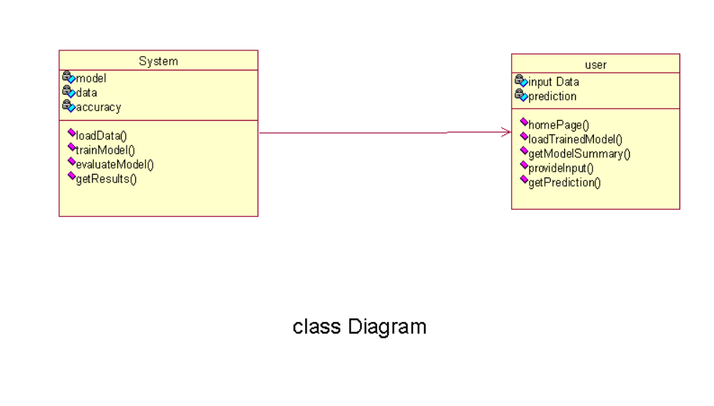.

**Figure 5.4.2: Class Diagram**

In the Unified Modeling language, a class diagram is a type of static structural diagram that displays the functions, interactions, and relationships between objects to depict a system's structure. The cornerstone of object-oriented modeling is the class diagram. Image, build dataset, pre-processing, segmentation, and classification are the classes represented in together with the corresponding properties, processes, and relationships between those classes.

* + 1. **SEQUENCE DIAGRAM**

In the Unified Modelling Language (UML), a sequence diagram is a type of interaction diagram that illustrates the order and relationship between activities. A message sequence chart is the name given to it. Sequence diagrams include timing diagrams, event-trace diagrams, and representations of event contexts. One can also refer to a sequence diagram as an event diagram or an event scenario. Sequence diagrams show how a system's components interact with one another. The requirements for both new and current systems are frequently described and understood by entrepreneurs and software engineers using these diagrams.

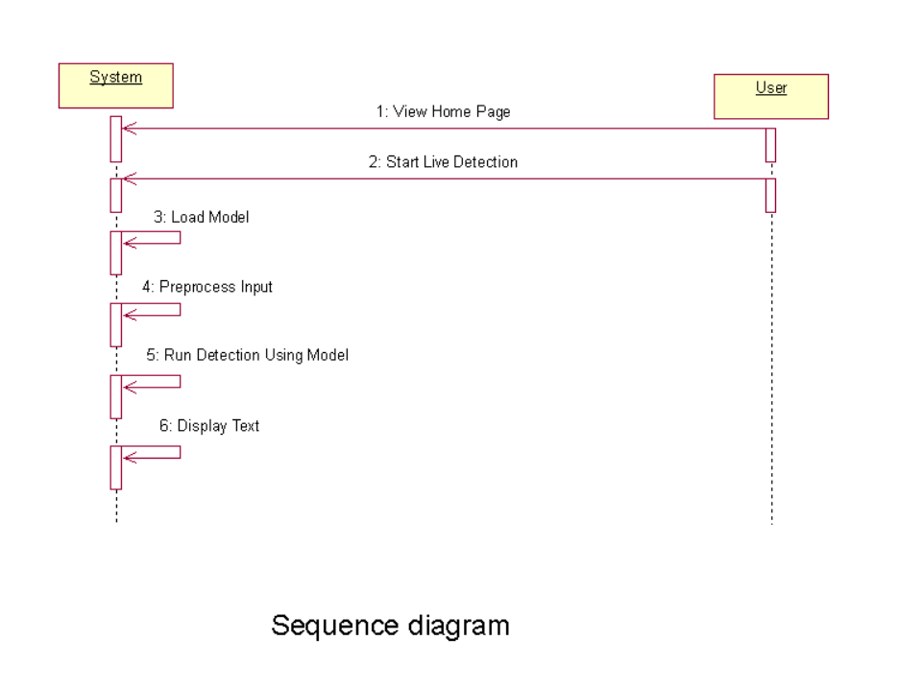

**Figure 5.4.3: Sequence Diagram**

* + 1. **COLLABORATION DIAGRAM**

The method call sequence in a collaboration diagram is indicated by some numbering technique, as shown below. The number indicates the order in which the methods are called. The collaboration diagram is described using the same order management system. The method calls resemble those of a sequence diagram. The difference is that the sequence diagram does not describe the object organization, whereas the collaboration diagram does.

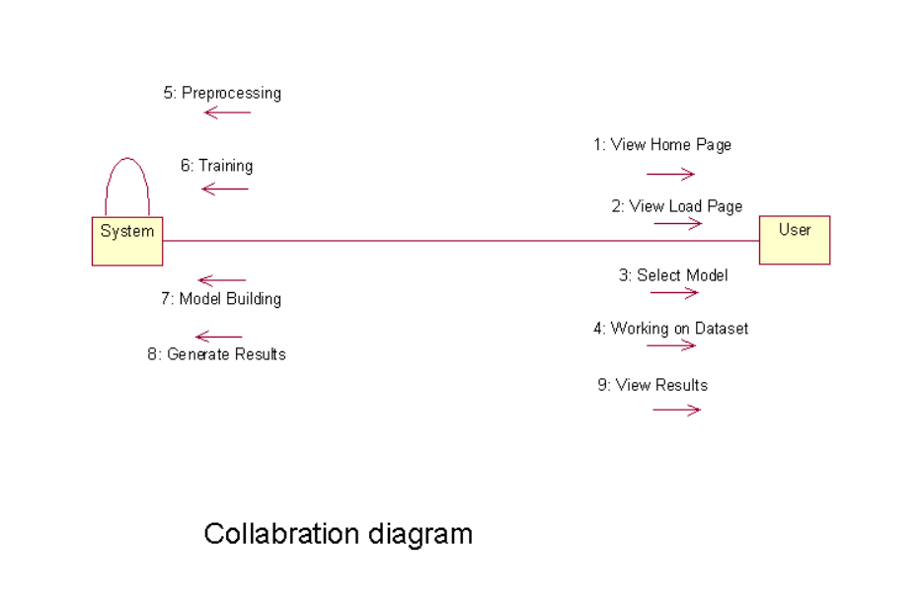

**Figure 5.4.4: Collaboration Diagram**

* + 1. **DEPLOYMENT DIAGRAM**

The hardware and software components that make up a deployment are described using deployment diagrams. Diagrams of components and deployments have a lot in common. Diagrams of the components' deployment in hardware are shown in deployment diagrams, which are used to describe the components.

The software artefacts of a system are the primary emphasis of UML. However, these two particular diagrams are meant to highlight the hardware and software parts. In contrast to deployment diagrams, which are designed to concentrate on a system's hardware topology, most UML diagrams are used to manage logical components. The system engineers utilize diagrams for deployment. You can characterize the function of deployment diagrams as:

* Think about how a system's hardware is organized.
* Explain the hardware elements that are deployed in order to run software components.
* Tell us about the runtime processing nodes.

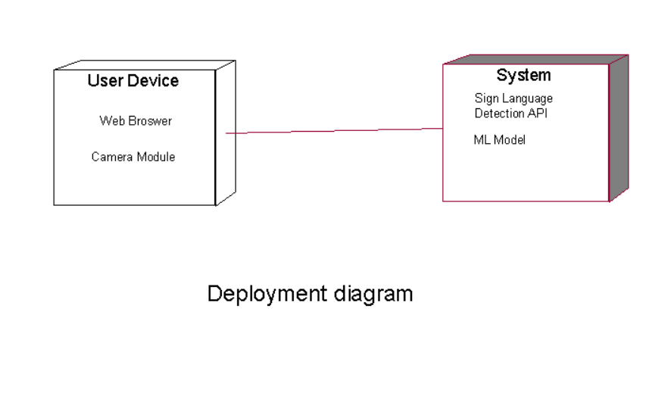

**Figure 5.4.5: Deployment Diagram**

* + 1. **ACTIVITY DIAGRAM**

Activity diagrams offer choice, iteration, and concurrency in their depiction of the work flows of evolving tasks and actions. The operational and business processes of system components can be represented in detail using activity flowcharts in the Unified Modified Language.

An activity diagram illustrates the entire control flow With the activity diagram, you can keep track of the sequence of actions occurring in your system. Activities look like states; however, they are a little more rounded.The "diamond" conditional branch determines which activity to switch to based on a characteristic and is also stateless. Activity Diagram includes

* Action states.
* Transition.
* Objects.
* Contains Fork, Join and branching relations along with flow Chart symbols.

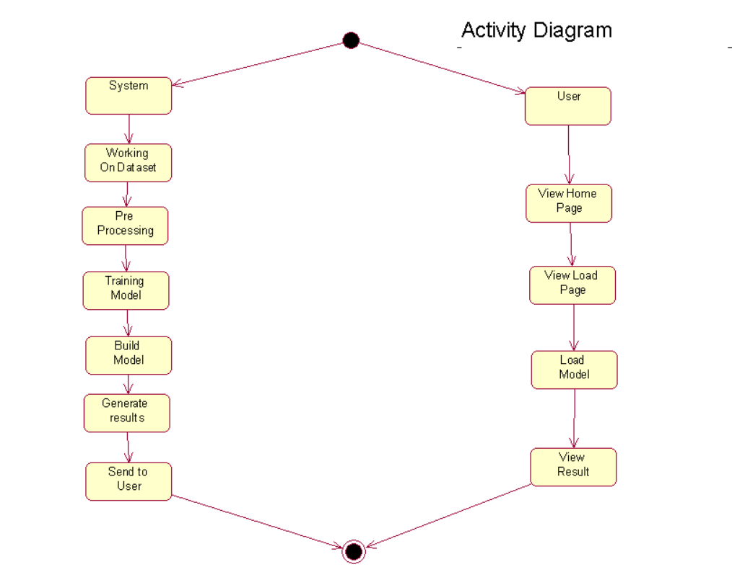

. **Figure 5.4.6: Activity Diagram**

* + 1. **COMPONENT DIAGRAM**

A specific type of diagram in UML is called a component diagram. The goal is also distinct from the previous diagrams mentioned. Although it defines the components utilized to provide certain functionalities, it does not describe the system's functionality as a whole.

The entire system cannot be represented by a single component diagram; instead, a collection of diagrams is employed. The component diagram's goal can be summed up as follows:

1. Identify the parts of a system visually.
2. Use both forward and reverse engineering to create executables.

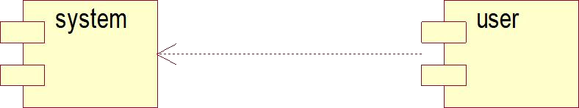

**Figure 5.4.7: Component Diagram**

# 

# CHAPTER-6

**SYSTEM CODING AND IMPLEMENTATION**

#### SYSTEM CODING AND IMPLEMENTATION

* 1. Introduction to python programming language:

Popular computer language Python is renowned for its simple syntax, scalability, and application in artificial intelligence (AI) and machine learning. Python is a key component of the systems used by some of the biggest companies in the world, including Google, NASA, and Facebook. Python is an object-oriented programming language. By definition, it is a high- level programming language, enabling the construction of both simple and complex processes. **Features :**

* Simple
* Easy
* Portable
* Object oriented
* High Level
* Open Source and Free
* Support for GUI
* Interpreted
* Dynamic
* Readable
* Scalable

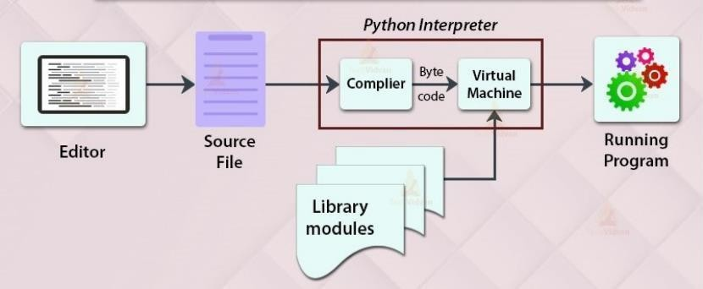

**Figure 6.1 working of python program**

Similar to Java, Python is an object-oriented programming language. The term "interpreted language" refers to Python. Instead of a single lengthy list of instructions, which was the norm for functional programming languages, Python uses interchangeable code modules.

"python" is the name of the preferred Python implementation. It serves as Python's default and most used implementation.Python does not translate its code into hardware-understandable machine code. In actuality, it transforms it into byte code. Compilation does take place in Python, but not into a machine language. It is encoded in byte code (.pyc or.pyo), which the CPU is unable to understand. To execute the byte codes, we therefore require an interpreter known as the Python virtual machine.

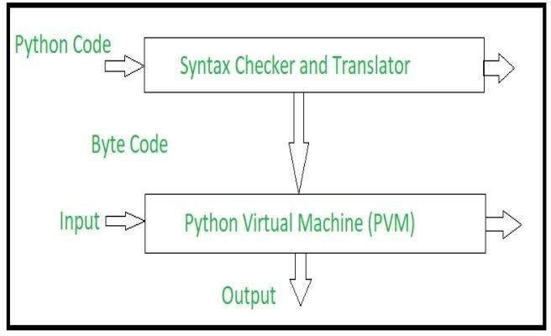

**Figure 6.2 Implementation of python program**

**Python source code goes through the following to generate an executable code :**

**Step 1:** The python compiler reads a python source code or instruction. Then it verifies that the instruction is well-formatted, i.e. it checks the syntax of each line. If it encounters an error, it immediately halts the translation and shows an error message.

**Step 2:** If there is no error, i.e. if the python instruction or source code is well-formatted then the compiler translates it into its equivalent form in an intermediate language called “Byte code”.

**Step 3:** Byte code is then sent to the Python Virtual Machine(PVM) which is the python interpreter. PVM converts the python byte code into machine-executable code. If an error occurs during this interpretation then the conversion is halted with an error message.

###### BENEFITS OF PYTHON

* Python may be used to create prototypes, and because it is so simple to use and read, it can be done rapidly.
* The majority of platforms for automation, data mining, and big data rely on Python.
* Compared to large languages like C# and Java, Python offers a more productive coding environment. By using Python, seasoned programmers tend to stay more organised and productive.
* Even if you're not an experienced programmer, Python is simple to read. Everyone can start using the language; all it needs is some perseverance and lots of practise.
* Additionally, this makes it a perfect choice for use by large development teams and teams with multiple programmers.
* Django is a full and open-source web application framework that is powered by Python. The process of developing software can be made simpler by using frameworks like Ruby on Rails.
* Because it was built by the community and is open source, it has a huge fan base. Millions of like-minded programmers use the language every day and keep its foundational features up to date. As time goes on, Python's most recent version continues to get updates and improvements. This is a fantastic method of connecting with other developers.
  1. LIBRARIES USED IN PYTHON

**Pandas:** Pandas is a versatile open-source Python library widely used for data manipulation, analysis, and preparation in data science and machine learning workflows. Built on top of NumPy, it leverages the power of multidimensional arrays while introducing higher-level data structures like Series (one-dimensional) and DataFrame (two-dimensional). These structures allow for intuitive handling of labeled and tabular data, making tasks such as data cleaning, transformation, and exploration more efficient.

**NumPy:** NumPy is a powerful Python library designed for numerical computing and handling multi-dimensional arrays and matrices. It provides an extensive collection of mathematical functions to perform operations such as element-wise computations, matrix manipulations, and linear algebra. Beyond its array operations, NumPy offers tools for Fourier transformations, random number generation, and advanced statistical calculations, making it indispensable for scientific computing.

**Matplotlib:** The Python library for numerical mathematics, seamlessly integrates with Matplotlib, a popular Python-based plotting library. This combination allows users to create visually appealing and detailed graphs and plots directly from numerical data.

Matplotlib offers an object-oriented API, enabling smooth integration of charts into graphical user interface (GUI) toolkits like Tkinter, wxPython, and Qt. With its extensive customization options, users can generate line charts, scatter plots, histograms, and more to visualize complex datasets effectively.

**Sklearn:** Scikit-learn, a widely used Python library for machine learning, provides an extensive suite of tools for classification, regression, and clustering. Some of its core algorithms include support vector machines (SVMs), random forests, gradient boosting, k-means, and DBSCAN. As an open-source library, Scikit-learn is known for its simplicity, flexibility .

**TensorFlow:** TensorFlow is an open-source Python library developed by Google for high- performance numerical computation and machine learning. Designed for scalability, TensorFlow is widely used for building and deploying deep learning models across various platforms, from desktops to mobile devices and even large-scale distributed systems. It provides a flexible architecture with tools for defining, training, and optimizing machine learning models using computational graphs. TensorFlow supports a wide range of operations, including matrix computations, automatic differentiation, and GPU acceleration, enabling efficient handling of large datasets and complex algorithms. Additionally, high-level wrapper libraries such as Keras are built on TensorFlow, simplifying the process of creating and training deep learning models with an intuitive and user-friendly API.

**PyCharm:**

PyCharm is a popular Python IDE. There are several reasons for this, one of which is that it was created by JetBrains, the company that also created the well-known IntelliJ IDEA IDE, one of the "big 3" Java IDEs, and WebStorm, the "smartest JavaScript IDE."Another compelling reason is the availability of Django support for web development.

Pycharm created this IDE primarily for Python programming and to run on various operating systems such as Windows, Linux, and macOS. The IDE includes version control, a debugger, testing tools, and code analysis tools. It also assists programmers in creating Python plugins by leveraging the numerous APIs available.The IDE allows us to work directly with a variety of databases without having to integrate them with other programmes. Despite being designed specifically for Python, this IDE also supports HTML, CSS, and other markup languages,Javascript documents.

In addition to its robust features, PyCharm offers seamless integration with popular Python libraries and frameworks such as Flask, Pandas, NumPy, and TensorFlow, making it ideal for a wide range of applications from web development to data science and machine learning. The smart code navigation and autocomplete features significantly enhance productivity by allowing developers to quickly locate and refactor code. PyCharm’s integrated terminal and support for Jupyter notebooks streamline the workflow for developers working on data-driven projects. The IDE also includes customizable themes and keyboard shortcuts, providing a highly personalized development environment. For team collaboration, it offers seamless integration with version control systems like Git, ensuring efficient project management. Furthermore, the ability to create and manage virtual environments directly within the IDE simplifies dependency management and ensures project consistency across systems.

* 1. **Sample Code**

import streamlit as st import numpy as np import cv2

from tensorflow.keras.models import load_model import matplotlib.pyplot as plt

from sklearn.metrics import accuracy_score, classification_report, confusion_matrix import seaborn as sns

from sklearn.metrics import ConfusionMatrixDisplay import mediapipe as mp

from tensorflow.keras.models import Sequential

from tensorflow.keras.layers import Dense, Conv2D, MaxPooling2D, Flatten, Dropout from tensorflow.keras.optimizers import Adam

from sklearn.model_selection import train_test_split from sklearn.preprocessing import LabelBinarizer

from tensorflow.keras.callbacks import LambdaCallback import pandas as pd

import json

from streamlit_lottie import st_lottie

def load_lottie_local(filepath: str): with open(filepath, "r") as file:

return json.load(file)

mp_hands = mp.solutions.hands

h a n d s = m p _ h a n d s . H a n d s ( s t a t i c _ i m a g e _ m o d e = Fa l s e , m a x _ n u m _ h a n d s = 1 , min_detection_confidence=0.5)

mp_drawing = mp.solutions.drawing_utils # Function to get letter from prediction def getLetter(result):

classLabels = {0: 'A', 1: 'B', 2: 'C', 3: 'D', 4: 'E', 5: 'F', 6: 'G', 7: 'H', 8: 'I', 9: 'K',

10: 'L', 11: 'M', 12: 'N', 13: 'O', 14: 'P', 15: 'Q', 16: 'R', 17: 'S', 18: 'T',

19: 'U', 20: 'V', 21: 'W', 22: 'X', 23: 'Y'}

try:

res = int(result)

return classLabels[res]

except:

return "Error"

# Sidebar sections st.sidebar.title("Sign Detection")

section = st.sidebar.selectbox("Choose a section", ["Home", "Data Loading & Model Training", "Predictions", "Visualizations", "Reports"])

# Home section

if section == "Home":

st.title("Sign Language Detection System") # Path to your Lottie JSON animation file

lottie_file_path = "Animation - 1729326514388.json" # Replace with your Lottie file path

# Load and display the Lottie animation lottie_animation = load_lottie_local(lottie_file_path)

st_lottie(lottie_animation, speed=1, width=700, height=400, key="home_animation")

st.write("""

Welcome to the Sign Language Detection System! This application utilizes advanced machine learning techniques

to recognize sign language gestures in real-time, making it a powerful tool for enhancing communication

between hearing and deaf communities. """)

st.write("""

### Key Features:

* **Real-time Gesture Recognition**: The application captures gestures from a live webcam feed and

predicts the corresponding sign language letter.

- **User-Friendly Interface**: Designed with simplicity in mind, making it accessible for users of all

ages and technical backgrounds.

* **Robust Model**: Built on a Convolutional Neural Network (CNN) that has been trained on a diverse dataset, ensuring high accuracy in sign recognition.

""")

# Data Loading & Model Training

elif section == "Data Loading & Model Training": st.title("Data Loading & Model Training")

# Load dataset st.subheader("Loading Dataset")

train = pd.read_csv("sign_mnist_train.csv") test = pd.read_csv("sign_mnist_test.csv")

st.write("Training data preview:") st.write(train.head())

labels = train['label'].values

# Preprocess data st.subheader("Preprocessing Data") train.drop('label', axis=1, inplace=True) images = train.values

images = np.array([np.reshape(i, (28, 28)) for i in images]) images = np.array([i.flatten() for i in images])

# Binarize labels

label_binarizer = LabelBinarizer()

labels = label_binarizer.fit_transform(labels)

# Split the dataset

x_train, x_test, y_train, y_test = train_test_split(images, labels, test_size=0.3, random_state=101)

# Normalize data x_train = x_train / 255 x_test = x_test / 255

x_train = x_train.reshape(x_train.shape[0], 28, 28, 1)

x_test = x_test.reshape(x_test.shape[0], 28, 28, 1)

st.write("Shape of Training data:", x_train.shape)

# Model Training st.subheader("Training Model") batch_size = 128

num_classes = 24

epochs = 10

# Initialize progress bar progress_bar = st.progress(0)

# Create model model = Sequential()

model.add(Conv2D(64, kernel_size=(3, 3), activation='relu', input_shape=(28, 28, 1)))

model.add(MaxPooling2D(pool_size=(2, 2))) model.add(Conv2D(64, kernel_size=(3, 3), activation='relu')) model.add(MaxPooling2D(pool_size=(2, 2))) model.add(Conv2D(64, kernel_size=(3, 3), activation='relu')) model.add(MaxPooling2D(pool_size=(2, 2))) model.add(Flatten())

model.add(Dense(128, activation='relu')) model.add(Dropout(0.20)) model.add(Dense(num_classes, activation='softmax'))

# Compile model

model.compile(loss='categorical_crossentropy', optimizer=Adam(), metrics=['accuracy'])

# Train the model with a progress bar

history = model.fit(x_train, y_train, validation_data=(x_test, y_test), epochs=epochs, batch_size=batch_size,

callbacks=[LambdaCallback(on_epoch_end=lambda epoch, logs: progress_bar.progress((epoch+1)/epochs))])

# Save the model and history to session state st.session_state.model = model st.session_state.history = history.history st.session_state.x_test = x_test st.session_state.y_test = y_test

model.save('Model.keras') model.save('Model1.h5')

st.success("Model training completed!")

# Predictions section (Live webcam) elif section == "Predictions":

st.title("Live Sign Prediction") model = load_model('Model.keras') run = st.checkbox('Run webcam') FRAME_WINDOW = st.image([])

# Access webcam

camera = cv2.VideoCapture(0)

while run:

ret, frame = camera.read() if not ret:

st.warning("Could not access the webcam.") break

# Flip the frame horizontally for a selfie view frame = cv2.flip(frame, 1)

# Convert the BGR image to RGB before processing frame_rgb = cv2.cvtColor(frame, cv2.COLOR_BGR2RGB)

# Process the frame with MediaPipe Hands results = hands.process(frame_rgb)

# Draw hand landmarks and bounding boxes if hands are detected if results.multi_hand_landmarks:

for hand_landmarks in results.multi_hand_landmarks: # Draw hand landmarks

m p _ d r a w i n g . d r a w _ l a n d m a r k s ( f r a m e , h a n d _ l a n d m a r k s , mp_hands.HAND_CONNECTIONS)

# Get the bounding box for the hand h, w, _ = frame.shape

x_min = int(min([lm.x for lm in hand_landmarks.landmark]) * w) y_min = int(min([lm.y for lm in hand_landmarks.landmark]) * h) x_max = int(max([lm.x for lm in hand_landmarks.landmark]) * w) y_max = int(max([lm.y for lm in hand_landmarks.landmark]) * h)

# Draw bounding box around the hand

cv2.rectangle(frame, (x_min, y_min), (x_max, y_max), (255, 0, 0), 2)

# Extract hand region for prediction (resize it to 28x28) hand_region = frame[y_min:y_max, x_min:x_max]

img_gray = cv2.cvtColor(hand_region, cv2.COLOR_BGR2GRAY) img_resized = cv2.resize(img_gray, (28, 28))

# Reshape and normalize the image

img_array = img_resized.reshape(1, 28, 28, 1) / 255.0

# Make predictions

prediction = model.predict(img_array) predicted_class = np.argmax(prediction, axis=1) letter = getLetter(predicted_class)

# Overlay the prediction on the frame font = cv2.FONT_HERSHEY_SIMPLEX

cv2.putText(frame, f'Prediction: {letter}', (x_min, y_min - 10), font, 1, (0, 255, 0), 2, cv2.LINE_AA)

# Convert the frame to RGB for Streamlit and display it frame_rgb = cv2.cvtColor(frame, cv2.COLOR_BGR2RGB) FRAME_WINDOW.image(frame_rgb)

camera.release()

# Visualizations section

elif section == "Visualizations":

st.title("Model Accuracy, Loss, and Metrics")

# Check if history is available in session state if 'history' in st.session_state:

history = st.session_state.history

# Plot accuracy and loss curves st.subheader("Accuracy over epochs")

# Plot accuracy

fig, ax = plt.subplots(figsize=(10, 5)) ax.plot(history['accuracy'], label='Training Accuracy') ax.plot(history['val_accuracy'], label='Validation Accuracy') ax.set_xlabel('Epochs')

ax.set_ylabel('Accuracy') ax.legend()

st.pyplot(fig) # Pass the figure explicitly

st.subheader("Loss over epochs") # Plot loss

fig, ax = plt.subplots(figsize=(10, 5)) ax.plot(history['loss'], label='Training Loss') ax.plot(history['val_loss'], label='Validation Loss') ax.set_xlabel('Epochs')

ax.set_ylabel('Loss') ax.legend()

st.pyplot(fig) # Pass the figure explicitly

# Display confusion matrix x_test = st.session_state.x_test y_test = st.session_state.y_test model = st.session_state.model

y_pred = model.predict(x_test) y_pred_classes = np.argmax(y_pred, axis=1) y_true = np.argmax(y_test, axis=1)

cm = confusion_matrix(y_true, y_pred_classes) fig, ax = plt.subplots()

sns.heatmap(cm, annot=True, fmt='d', ax=ax) ax.set_xlabel('Predicted') ax.set_ylabel('True')

st.pyplot(fig) # Pass the figure explicitly

# Display accuracies st.subheader("Model Accuracies")

st.write(f"Training Accuracy: {st.session_state.history['accuracy'][-1]:.2f}") st.write(f"Validation Accuracy: {st.session_state.history['val_accuracy'][-1]:.2f}")

else:

st.warning("Train the model first to see the visualizations.")

# Reports section

elif section == "Reports": st.title("Model Reports")

# Check if model and test data are available

if 'model' in st.session_state and 'x_test' in st.session_state and 'y_test' in st.session_state: model = st.session_state.model

x_test = st.session_state.x_test y_test = st.session_state.y_test

y_pred = model.predict(x_test) y_pred_classes = np.argmax(y_pred, axis=1) y_true = np.argmax(y_test, axis=1)

st.subheader("Classification Report")

report = classification_report(y_true, y_pred_classes, target_names=[f'Class {i}' for i in range(len(set(y_true)))])

st.text(report) else:

st.warning("Train the model first to generate reports.")

# CHAPTER-7 SYSTEM TESTING

#### SYSTEM TESTING

###### SOFTWARE TESTING TECHNIQUES

Software testing is a method for evaluating the quality of software products and identifying defects so that they can be rectified. Software testing makes an effort to accomplish its goals, but there are significant constraints. On the other side, for testing to be effective, dedication to the set objectives is required.

* + 1. Testing Objectives
* The user stories, designs, specifications, and code that make up the work products
* To ensure that all conditions are satisfied.
* Ensuring that the test object is complete and meets the expectations of users and stakeholders
  + 1. Test Case Design

Every engineering product can be tested in one of these.

###### TESTING OF A WHITE BOX

Black box testing and white box testing are two types of software testing methodologies. White Box testing, also known as structural testing, clear box testing, open box testing, and transparent box testing, is covered in this article. It focuses on evaluating the infrastructure and software's fundamental code against current inputs and anticipated and desired outcomes. It emphasises internal structure analysis and is focused on a program's internal activities. To construct test cases for this type of testing, programming knowledge is needed. Focusing on the inputs and outputs of the software while also ensuring its security is the core aim of white box testing. The phrases "clear box," "white box," and "transparent box" all allude to being able to see through the exterior covering of the software. White testing a box is used by designers. This stage involves testing every line of the program's code. Prior to handing off the programme or software to the testing team, the developers run white-box testing on it to ensure that it conforms with the requirements and to identify any mistakes.

Before releasing the project to the testing team, the developer fixes the issues and does one round of white box testing. In this case, fixing problems includes removing the problem and activating the specific functionality of the application. For the following reasons, the test engineers won't be helping to fix the problems: Resolving the problem might impair other features. As a result, developers should keep making advancements while the test engineer should constantly look for faults. If the test engineers spend most of their time fixing problems, they might not be able to find any new flaws in the program.

White box testing is essential for uncovering vulnerabilities and ensuring that the code meets the required standards of performance and security. By examining the internal workings of the software, developers can detect logical errors, potential security breaches, and other critical issues that might not be apparent through external testing alone. This method is particularly effective in optimizing code efficiency and robustness, as it allows developers to scrutinize individual paths and conditions within the code. Through meticulous inspection, developers can verify that each module or component functions correctly and integrates seamlessly with the rest of the system. Furthermore, white box testing promotes better coding practices by enforcing a high level of scrutiny and discipline. Developers are encouraged to write cleaner, more maintainable code, knowing that every line will be examined for potential flaws. This leads to improved software quality and a reduction in long-term maintenance costs.

Additionally, white box testing complements other testing methods, such as black box testing, by providing a comprehensive evaluation of the software. While black box testing assesses the software from the user's perspective, ensuring that all functionalities meet the specified requirements, white box testing delves deeper into the code's structure and behavior. Together, these methodologies ensure a well-rounded and thorough testing process, ultimately leading to more reliable and secure software.

The following tests are part of the white box testing:

* Path testing
* Loop testing
* Condition evaluation
* Testing from the viewpoint of memory
* Test results for the program

###### BLACK BOX TESTING

Testing software applications' functionalities without having access to the internal code structure, implementation details, or internal paths is known as "black box testing" in the software industry. The term "black box testing" refers to a sort of software testing that is solely concerned with the input and output of software program as well as the requirements and specifications for software. You are free to use any software package you choose as a Black- Box. A few examples include an Oracle database, a Google website, the Windows operating system, or even your own custom program. You can test these applications using black box testing by focusing just on their inputs and outputs and ignoring any awareness of how their underlying code is implemented. Black box testing is crucial in the software development process because it simulates real-world scenarios that end-users might encounter.

By focusing on the functionality rather than the internal mechanics, testers can identify how well the software performs under various conditions and whether it meets user expectations. This type of testing helps to validate that the software operates correctly from the user's perspective, ensuring that all features and functions behave as intended. It is especially useful for uncovering issues related to usability, performance, and compliance with requirements.

Moreover, black box testing is versatile and can be applied at different levels of software development, from individual units to entire systems. It allows testers to work independently of the development team, which can provide an unbiased assessment of the software's quality. Since the testers do not need to understand the code, black box testing can be performed by individuals with different skill sets, including those without programming expertise. This inclusivity broadens the scope of testing, allowing for a more diverse range of test cases and scenarios to be evaluated. By concentrating on the user experience and external behaviors, black box testing complements other testing methods, contributing to the overall robustness and reliability of the software.

The following locations are checked for faults by this technique:

1. Insufficiency or absence of capacities.
2. Interaction errors.
3. Inadequate information architecture.
4. Behaviour or execution errors.
5. Starting and finishing errors.

###### STRATEGIES FOR SOFTWARE TESTING

* + - * A unit test
      * Integrity Checks
      * Validation Examination
      * System Evaluation
      * Security Checks
      * Performance Evaluation
  1. Unit Testing

The module is the smallest piece of software architecture that is tested as part of unit testing. Within the constraints of the module, significant control channels are analysed using the procedural design description as a guide. The smallest testable parts of a programme, called units, are reviewed separately and independently during unit testing to guarantee proper operation. This testing process is used by software engineers and, on occasion, QA staff throughout the development phase.

The main objective of unit testing is to test and validate written code separately to ensure that it operates as intended. When done correctly, unit testing can help detect coding flaws that would otherwise be difficult to locate. TDD is a practical technique that regularly tests and enhances the product development process in a complete manner. One of the elements of TDD is unit testing. This method of testing serves as the initial phase of software testing and includes tests that come before integration testing and other types of testing. Unit testing verifies a unit's independence from any external code or functionalities. Manual testing is still an option even if automation testing is more popular. Unit testing, despite its focused scope, plays a crucial role in maintaining code quality throughout the software development lifecycle.

By isolating each unit, developers can ensure that every single component functions correctly on its own before integrating it into larger systems. This isolation allows for pinpointing specific issues and making adjustments without the risk of affecting other parts of the application. The practice also facilitates cleaner, more modular code, as developers are encouraged to write smaller, self-contained units that can be easily tested and maintained.

Furthermore, the benefits of unit testing extend beyond immediate bug detection. Well-written unit tests serve as a form of documentation for the code, providing insights into the expected behavior of each unit. This can be particularly valuable for new developers joining a project or for revisiting code after a long period. Automated unit testing frameworks enable the continuous integration and continuous delivery (CI/CD) pipelines, allowing for rapid feedback on code changes. This integration helps maintain the stability and reliability of the software, as any regressions or new issues can be quickly identified and addressed, ensuring a more robust and dependable final product.

* 1. Integration Testing

Integration testing is the process of creating a program's structure while running tests to find interface problems. To create a design-based programme structure, unit-tested methods are to be used. Integration testing is a testing procedure that conceptually connects and puts software components to the test. A typical software project consists of several software modules created by different programmers. This level of testing aims to find problems in the interactions between different software components when they are integrated. The interactions between these modules are examined during integration testing. Integration testing, often referred to as "I&T" (Integration and Testing), is essential for ensuring that the individual units of a software application work together as intended. Unlike unit testing, which focuses on testing individual components in isolation, integration testing evaluates the correctness of the interfaces and communication between these components. By doing so, it helps identify issues such as data mismatches, interface errors, and communication breakdowns that might not be evident when components are tested in isolation.

There are various approaches to integration testing, including the "Big Bang" approach, where all components are combined at once and tested as a complete system, and incremental integration testing, where components are progressively integrated and tested. Incremental approaches can be further divided into top-down and bottom-up integration testing. In top-down testing, higher- level modules are tested first, while in bottom-up testing, lower-level modules are tested first. Both methods help ensure that integration issues are identified and resolved early, contributing to a more reliable and seamless overall system.

Top-Down Integration:

The next step in the testing process is top-down integrations, a method for building and testing a program's structure progressively. Different modules in a software, product, or application are integrated by moving downward through the systematic control hierarchy between the modules, starting with the main control or home control or index program. The project's framework includes a variety of breadth- or depth-first activities or modules related to the primary program. In top-down integration testing, stubs are frequently used to simulate the behavior of lower-level modules that are not yet integrated. Stubs act as temporary replacements, providing the necessary responses to calls from the higher-level modules. This allows for the testing of the higher-level modules' functionality without waiting for all lower-level components to be completed. As integration progresses, these stubs are replaced with the actual modules, enabling comprehensive testing of the interactions and data flow within the software system. This approach helps identify any issues early in the integration process, making it easier to isolate and address problems.

The top-down integration method also facilitates early validation of the system architecture and high-level design decisions. By starting with the main control module and progressively integrating other modules, developers can ensure that the core functionalities are working as intended before dealing with more detailed and specific functionalities. This approach can be particularly beneficial in large and complex systems, where early detection of architectural issues can save significant time and resources. Additionally, top-down integration supports continuous feedback, allowing developers to refine and improve the system iteratively, ultimately leading to a more robust and reliable final product.

Bottom-up Integration:

The construction and testing of a few atomic modules, or the product's most basic features, is the first step in the subsequent testing methodology. Since all processes or modules are integrated bottom-up, there is no need for residual, and processing for modules tied to a certain level is always available. Bottom-up integration testing begins with the construction and testing of atomic modules, which are the most fundamental components of the system. These atomic modules are tested independently to ensure their functionality before being combined to form higher-level modules.

This method ensures that each component works correctly at its most basic level, providing a solid foundation for further integration. As modules are integrated from the bottom up, the need for stubs is eliminated, and the process remains consistent and manageable.

This approach also allows for immediate availability of processing for modules related to a specific level, streamlining the testing process. By building up from tested and verified lower- level modules, developers can incrementally combine them into more complex systems with confidence that the underlying components are robust. This method reduces the risk of encountering significant issues late in the development cycle, as potential problems are identified and resolved at each stage of integration. Bottom-up integration is particularly effective in systems where lower-level functionality is crucial to the overall performance, ensuring that the foundation is sound before adding more complex interactions.

* 1. Validation testing

Validation testing assures that the software developed and tested satisfies the client's or user's needs. Logic or scenarios for business requirements need to be thoroughly tested. Here, it is necessary to test every significant component of the application. You must always be able to validate the business logic or scenarios that are given to you as a tester.

One such method that encourages a careful examination of functioning is the validation process. Validation testing ensures that the programme has been tested and built to meet user or customer requirements. The justifications or scenarios for business demands must be thoroughly tested. Every key component of the application must be tested in this situation. As a tester, you will always be provided with scenarios or business logic that can be independently checked. One such process that helps in a detailed analysis of performance is the validation process. Validation testing is crucial in ensuring that the final software product aligns with the expectations and needs of the client or end-user. This testing phase involves rigorously checking that the software operates correctly under various conditions and scenarios that reflect real-world usage. The process involves validating not just the functional aspects, but also the performance, security, and usability of the application. By simulating actual user behavior and business processes, validation testing provides confidence that the software will perform as intended in its operational environment.

Moreover, validation testing is an ongoing process that often requires collaboration between testers, developers, and stakeholders. Continuous feedback loops help in identifying any discrepancies between the software's functionality and the user's requirements. This iterative approach ensures that any issues are promptly addressed, reducing the risk of major defects in the final product. Ultimately, validation testing serves as a final check before the software is released, ensuring that it meets the high standards expected by users and providing assurance that the application is reliable and fit for purpose.

* 1. System Testing

System testing's main goal is to rigorously test computer-based systems. Even though each test has a distinct goal, they all check to make sure that each system part is properly integrated in order to reach the objectives. Examining an entirely integrated software system is a component of system testing. A computer system is typically constructed by mixing software (any Software is the sole component of a computer system. The program is made up of modules that, when placed together with other pieces of software and hardware, form a complete computer system. In other words, a computer system is made up of numerous software program that perform various jobs. Software, however, is unable to carry out these duties alone.

System Testing requires the appropriate hardware must be used to help. System testing is a set of processes used to verify the overall functionality of a computer system that uses integrated software. The practise of system testing involves examining an application's or software's end-to- end flow from the viewpoint of a user. Each module required for an application is examined in detail, and systemic product testing is done to ensure that the final features and functionality function as planned. Since the testing environment mirrors the production environment, it is known as end-to-end testing. Validation testing also includes thorough documentation of test cases, results, and any defects encountered. This documentation serves as a valuable reference for future maintenance and updates, ensuring that any changes made to the software do not compromise its integrity. By systematically validating all aspects of the software, from functionality to user experience, validation testing plays a vital role in delivering a high-quality product that satisfies user requirements and performs reliably in real-world conditions.

* 1. Security testing

Security testing is an essential component of software testing since it enables us to identify vulnerabilities, risks, and hazards in software applications and protects our program from malevolent outsiders. Security testing's primary objective is to identify all of a program's potential ambiguities and vulnerabilities, which maintains the application operating. When we perform security testing, we might uncover any potential security risks and assist the programmer in resolving any issues. It is a method for ensuring data security while preserving software usability. Security testing encompasses a variety of techniques and strategies to thoroughly examine a software application for potential threats. These techniques include penetration testing, which simulates attacks to uncover vulnerabilities, and vulnerability scanning, which identifies known security issues within the code. Additionally, security testing often involves risk assessment to evaluate the likelihood and impact of potential threats. By doing so, it ensures that the application can withstand attempts at unauthorized access, data breaches, and other malicious activities.

Furthermore, security testing also involves code reviews and audits to identify and mitigate security flaws early in the development process. Regular security updates and patches are critical outcomes of ongoing security testing efforts, helping to maintain the application’s defense mechanisms against emerging threats. By prioritizing security testing, organizations can build more robust and resilient applications, protecting sensitive data and maintaining user trust. Overall, security testing is a proactive measure that significantly contributes to the long-term stability and security of software applications.

* 1. Performance Evaluation

Performance testing is a technique for assessing a system's responsiveness and stability under changing workloads. Performance testing assesses the dependability, scalability, and resource use of the system. Performance testing evaluates how well a system performs in terms of responsiveness and stability when subjected to various types of workloads and conditions. This type of testing helps in identifying bottlenecks, ensuring that the system can handle the expected load, and verifying that the performance criteria are met. By simulating different usage scenarios and stress levels, performance testing provides insights into how the system behaves under both normal and peak conditions. This includes measuring response times, throughput, and the system's ability to manage concurrent users or processes.

Additionally, performance testing is crucial for ensuring that the system can scale efficiently as user demand increases. It helps to uncover issues related to resource consumption, such as CPU and memory usage, and to determine whether the system can maintain optimal performance as it scales up or down. By conducting thorough performance testing, developers can optimize system performance, enhance user satisfaction, and prevent performance-related issues from affecting the overall user experience. This proactive approach helps in delivering a robust, high-performing system that meets both current and future demands.

**Performance Evaluation Method:**

Load testing is the simplest technique for evaluating how well a system will perform under a particular load. A load test's findings will show how much work is put on the application server, database, and other systems as well as the importance of key business transactions. Stress testing is carried out to ascertain the system's maximum capacity and how it will operate if the present load is greater than the predicted maximum. Soak tests, often called endurance tests, are used to evaluate a system's performance under a steady load. During soak testing, memory usage is monitored to identify performance issues like memory leaks. Monitoring the system's performance over time is the main objective. When testing during a "spike," the user base is rapidly expanded and the system's performance is swiftly examined. The main objective is to assess the system's workload management capabilities.

###### TEST CASES:

|  |  |  |
| --- | --- | --- |
| **Input** | **Output** | **Result** |
| Input Dataset | Providing Application | Success |

**Test cases Model building:**

|  |  |  |  |  |  |
| --- | --- | --- | --- | --- | --- |
| **S.NO** | **Test cases** | **Input** | **Expected O/T** | **Actual O/T** | **P/F** |
| 1 | View page | Dataset | Records | Showed Successfully | P |
| 2 | Model page | Applying algorithms | Fitting the Model | Applied Successfully | P |
| 3. | Prediction page | Entering Data- classify | P>N>N | Showed Successfully | P |

# CHAPTER-8 RESULTS

#### RESULTS

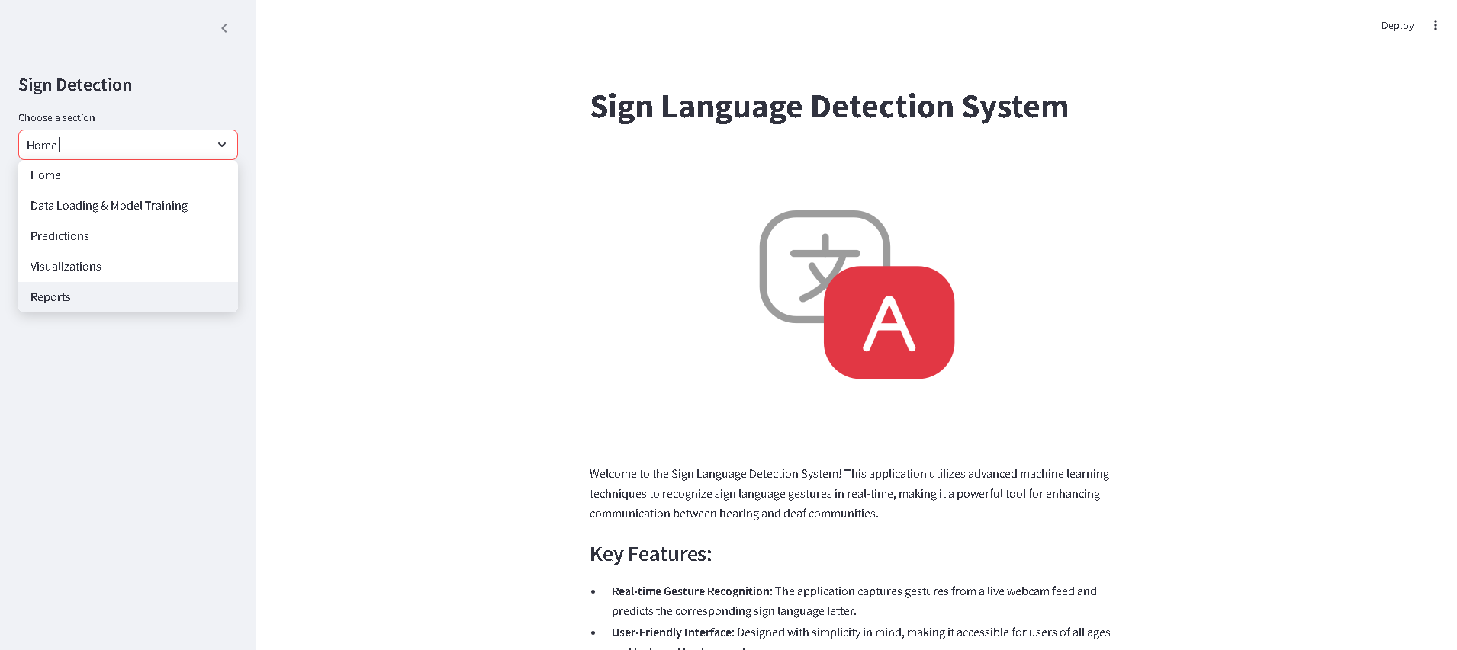

**Fig-8.1: Home Page**

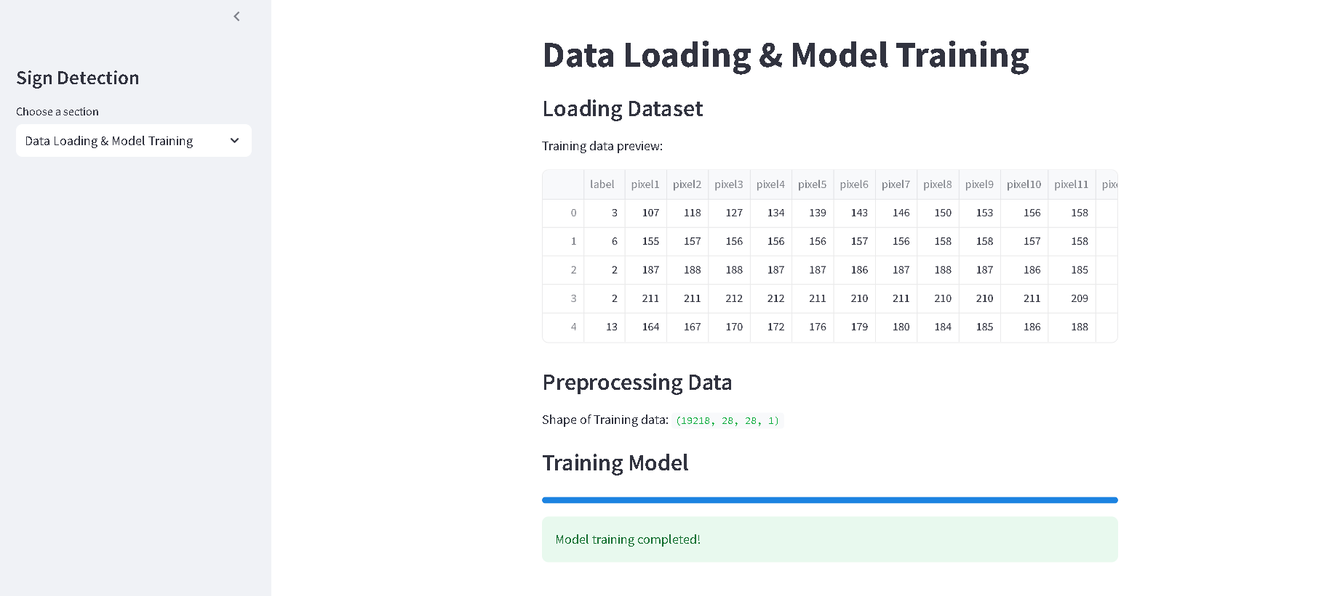

**Fig-8.2: Data Loading & Model Training**

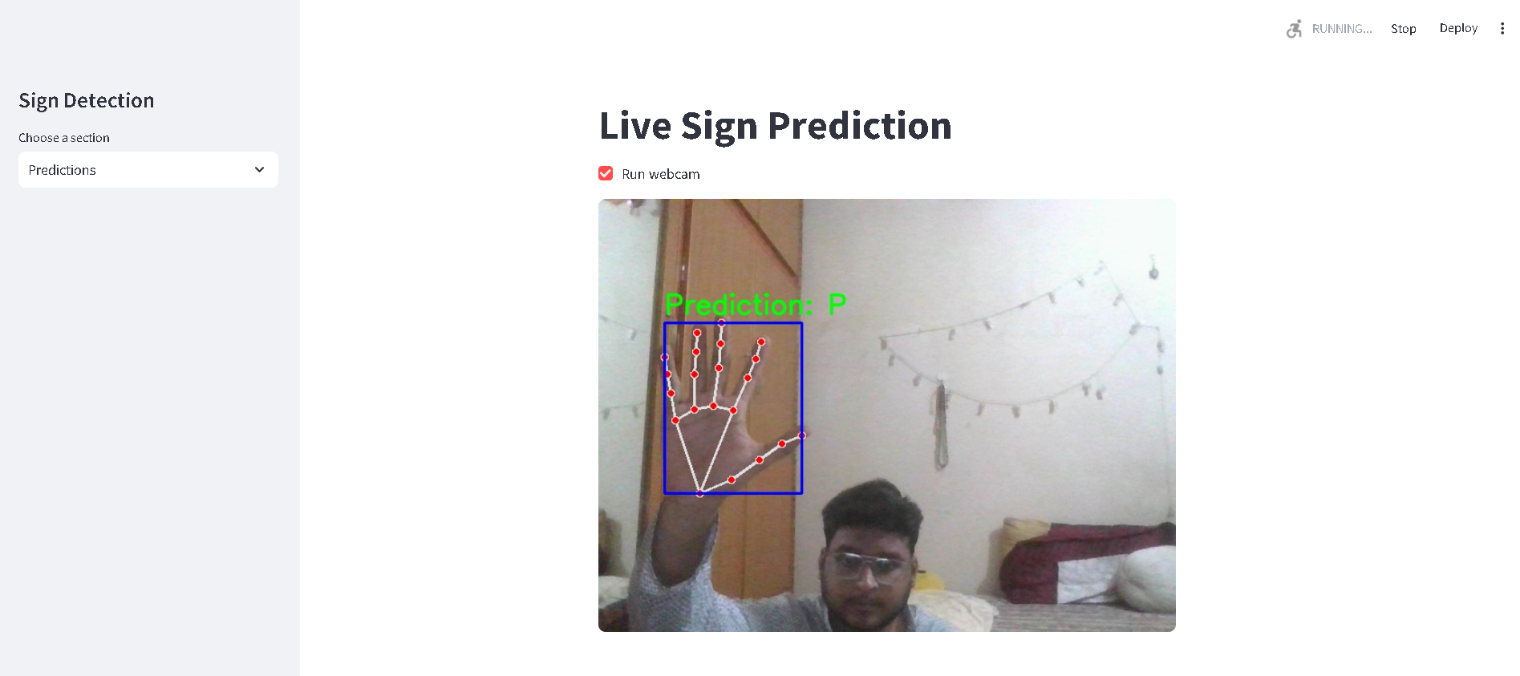

**Fig-8.3: Live Sign Prediction**

###### 

###### OUTPUT SCREENSHOTS WITH DESCRIPTION

**Fig-8.4: Image Processings**

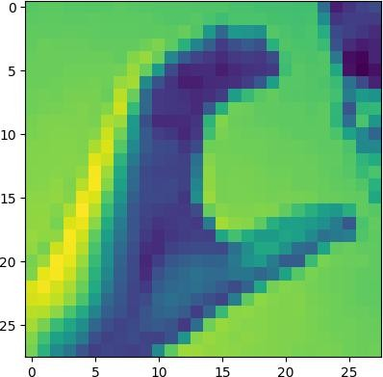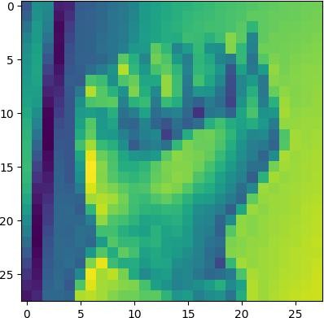

**Fig-8.5 : Live Predictions**

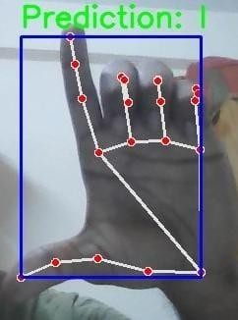

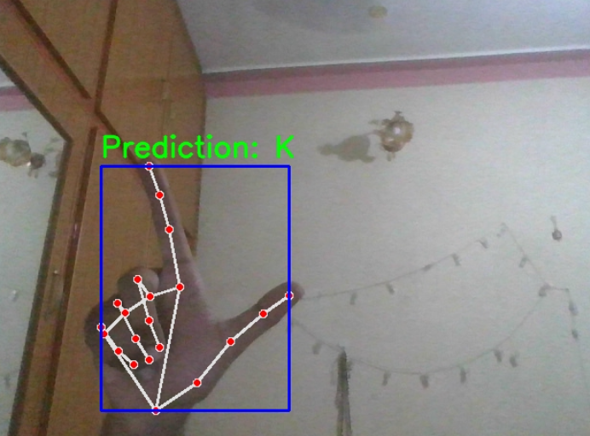

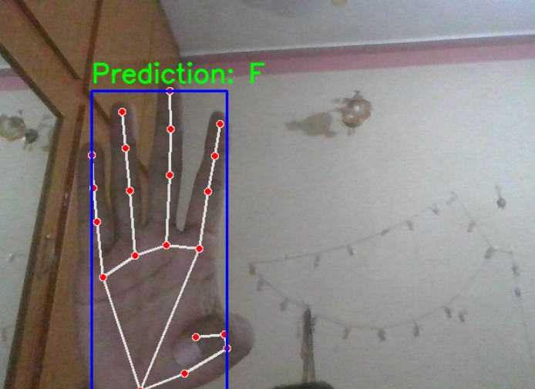

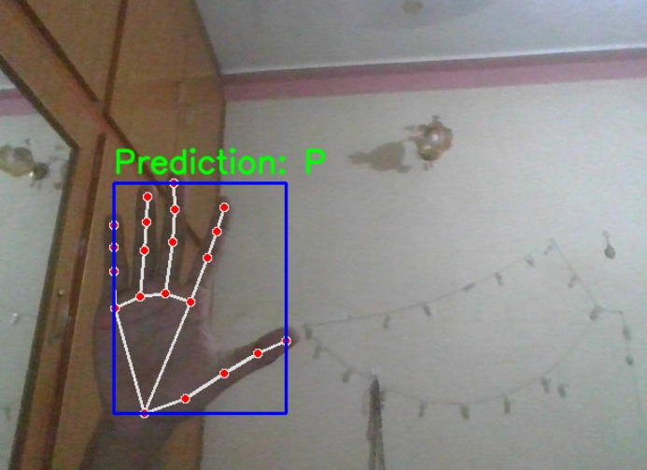

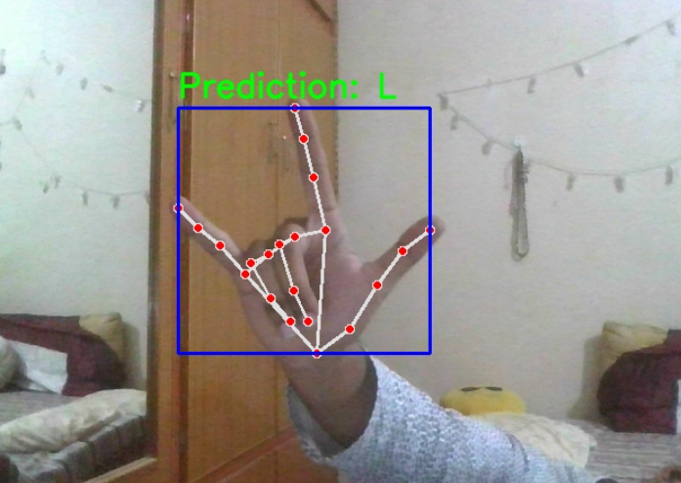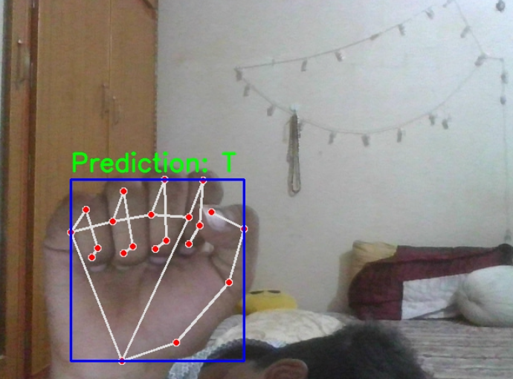

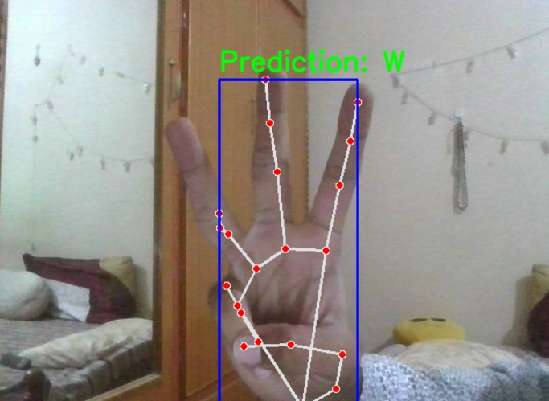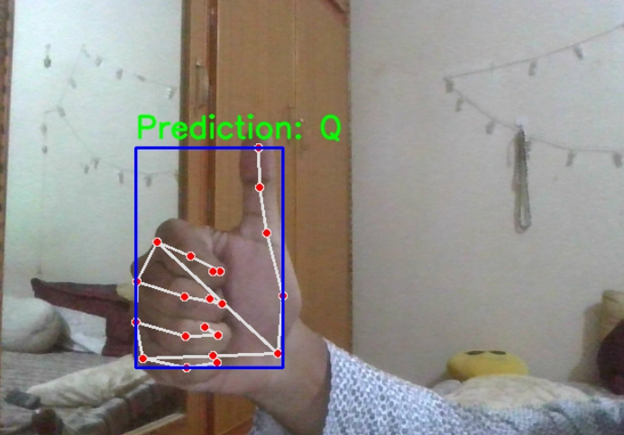

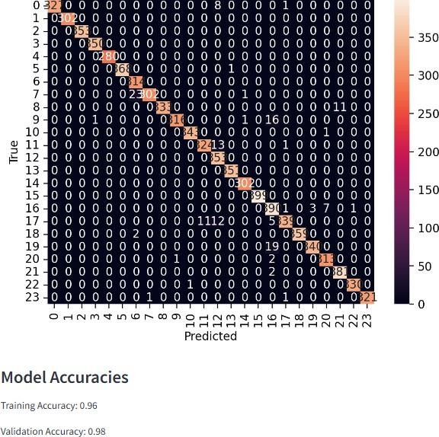

**Fig-8.6: Confusion Matrix**

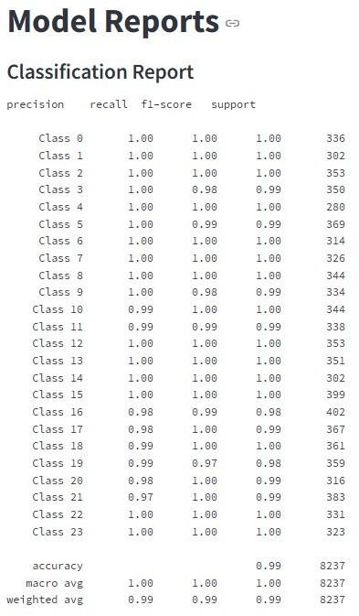

**Fig-8.7 : Classification Report**

## CHAPTER 9 CONCLUSION &

**FUTURE ENHANCEMENTS**

#### CONCLUSION

The Sign Language Recognition System developed using Convolutional Neural Networks (CNNs) highlights the effectiveness of deep learning in the field of gesture recognition. By leveraging CNN-based architecture, the system automates feature extraction, eliminating the need for manual preprocessing and enabling the model to capture complex hand gesture patterns. Preprocessing techniques like normalization, augmentation, and resizing further prepare the model to handle real-world challenges such as lighting, background noise, and image quality variations, enhancing its generalizability and reliability.

Additionally ,ensuring the model performs well on unseen data. The use of the Adam optimizer and categorical cross-entropy loss function supports efficient training, promoting quick convergence and effective inference. These design choices contribute to the system’s long-term performance and adaptability to new datasets, increasing its practical usability. Looking ahead, further optimization, integration with wearable devices or smartphones, and the use of larger and more diverse datasets could significantly improve the system’s accuracy and accessibility. This project ultimately underscores the potential of CNNs in enabling real-time sign language recognition, making a meaningful impact on communication for the hearing-impaired community.

#### FUTURE ENHANCEMENTS

One of the primary areas for future enhancement is improving the model's accuracy and robustness. Although the current system performs well across a range of sign language gestures, different sign language dialects, and diverse environmental conditions could significantly boost its performance .These improvements would make the model more resilient and adaptable, enabling it to function effectively in real-world scenarios with greater reliability.

Another promising enhancement is the integration of real-time feedback and interaction features to improve user experience. While the system currently recognizes gestures and delivers corresponding outputs, incorporating a user-friendly interface with immediate visual or auditory feedback—such as voice output or on-screen text translations—would greatly enhance accessibility, particularly in situations where individuals are unfamiliar with sign language. Personalization is also key—implementing adaptive learning mechanisms that tailor the system to individual users over time would make it more inclusive and accurate, improving performance across diverse user profiles and signing style.

###### REFERENCES

1. S. Alyami, H. Luqman, and M. Hammoudeh, ‘‘Isolated Arabic sign language recognition using a transformer-based model and landmark keypoints,’’ ACM Trans. Asian Low-Resource Lang. Inf. Process., vol. 23, no. 1, pp. 1–19, Jan. 2024.
2. G. J. Shin, A. S. M. Miah, K. Suzuki, K. Hirooka, and M. A. M. Hasan, ‘‘Dynamic Korean sign language recognition using pose estimation based and attention-based neural network,’’ IEEE Access, vol. 11, pp. 143501–143513, 2023.
3. N. Naz, H. Sajid, S. Ali, O. Hasan, and M. K. Ehsan, ‘‘Signgraph: An efficient and accurate pose-based graph convolution approach toward sign language recognition,’’ IEEE Access, vol. 11, pp. 19135–19147, 2023.
4. A. S. M. Miah, M. A. M. Hasan, S.-W. Jang, H.-S. Lee, and J. Shin, ‘‘Multi-stream general and graph-based deep neural networks for skeletonbased sign language recognition,’’ Electronics, vol. 12, no. 13, p. 2841, Jun. 2023.
5. A. Duarte, S. Palaskar, L. Ventura, D. Ghadiyaram, K. DeHaan, F. Metze, J. Torres, and X. Giro-i-Nieto, ‘‘How2Sign: A large-scale multimodal dataset for continuous American sign language,’’ in Proc. IEEE/CVF Conf. Comput. Vis. Pattern Recognit. (CVPR), Jun. 2021, pp. 2734–2743.
6. J. Zheng, Y. Chen, C. Wu, X. Shi, and S. M. Kamal, ‘‘Enhancing neural sign language translation by highlighting the facial expression information,’’ Neurocomputing, vol. 464, pp. 462–472, Nov. 2021.
7. L. Meng and R. Li, ‘‘An attention-enhanced multi-scale and dual sign language recognition network based on a graph convolution network,’’ Sensors, vol. 21, no. 4, p. 1120, Feb. 2021.
8. D. Li, C. R. Opazo, X. Yu, and H. Li, ‘‘Word-level deep sign language recognition from video: A new large-scale dataset and methods comparison,’’ in Proc. IEEE Winter Conf. Appl. Comput. Vis. (WACV), Mar. 2020, pp. 1448–1458.
9. X. Liang, A. Angelopoulou, E. Kapetanios, B. Woll, R. A. Batat, and T. Woolfe, ‘‘A multi- modal machine learning approach and toolkit to automate recognition of early stages of dementia among British sign language users,’’ in Proc. Eur. Conf. Comput. Vis., 2020, pp. 278–293.
10. O. Koller, N. C. Camgoz, H. Ney, and R. Bowden, ‘‘Weakly supervised learning with multi- stream CNN-LSTM-HMMs to discover sequential parallelism in sign language videos,’’ IEEE Trans. Pattern Anal. Mach. Intell., vol. 42, no. 9, pp. 2306–2320, Sep. 2020.

1. X. Liang, A. Angelopoulou, E. Kapetanios, B. Woll, R. A. Batat, and T. Woolfe, ‘‘A multi- modal machine learning approach and toolkit to automate recognition of early stages of dementia among British sign language users,’’ in Proc. Eur. Conf. Comput. Vis., 2020, pp. 278–293.
2. A. Almutairi, R. Alshahrani, and M. Alshahrani, “Deep Learning for Sign Language Recognition: A Survey,” IEEE Access, vol. 8, pp. 78851–78865, 2020.
3. F. Yang, Y. Yu, and Y. Yan, “Real-Time Sign Language Recognition System Based on Convolutional Neural Network,” Journal of Ambient Intelligence and Humanized Computing, vol. 11, no. 1, pp. 131–142, 2020.
4. R. Cui, H. Liu, and C. Zhang, ‘‘A deep neural framework for continuous sign language recognition by iterative training,’’ IEEE Trans. Multimedia, vol. 21, no. 7, pp. 1880–1891, Jul. 2019.
5. H. G. B. Li, H. X. Chen, and Y. C. Huang, “Hand Gesture Recognition Using Depth Sensors: A Survey,” Sensors, vol. 19, no. 22, p. 4871, 2019.
6. N. M. Akshaya and D. V. R. K. Chaitanya, “A Novel Approach for Sign Language Recognition Using Deep Learning Techniques,” International Journal of Innovative Technology and Exploring Engineering (IJITEE), vol. 8, no. 12, pp. 1932-1936, 2019.
7. N. K. Caselli, Z. S. Sehyr, A. M. Cohen-Goldberg, and K. Emmorey, ‘‘ASL-LEX: A lexical database of American sign language,’’ Behav. Res. Methods, vol. 49, no. 2, pp. 784–801, Apr. 2017.
8. D. Bahdanau, K. Cho, and Y. Bengio, ‘‘Neural machine translation by jointly learning to align and translate,’’ 2014, arXiv:1409.0473.
9. N. Pugeault and R. Bowden, ‘‘Spelling it out: Real-time ASL fingerspelling recognition,’’ in Proc. IEEE Int. Conf. Comput. Vis. Workshops (ICCV Workshops), Nov. 2011, pp. 1114– 1119.
10. U. von Agris, M. Knorr, and K.-F. Kraiss, ‘‘The significance of facial features for automatic sign language recognition,’’ in Proc. 8th IEEE Int. Conf. Autom. Face Gesture Recognit., Sep. 2008, pp. 1–6.

**PLAGIARISM REPORT**

**CONFERENCE PARTICIPATION CERTIFICATES**



